**CLOUD**

**Question**

**Steps:**

**Here I am designing a secure and functional cloud infrastructure using aws services**

**For creating the IAM user click on IAM**

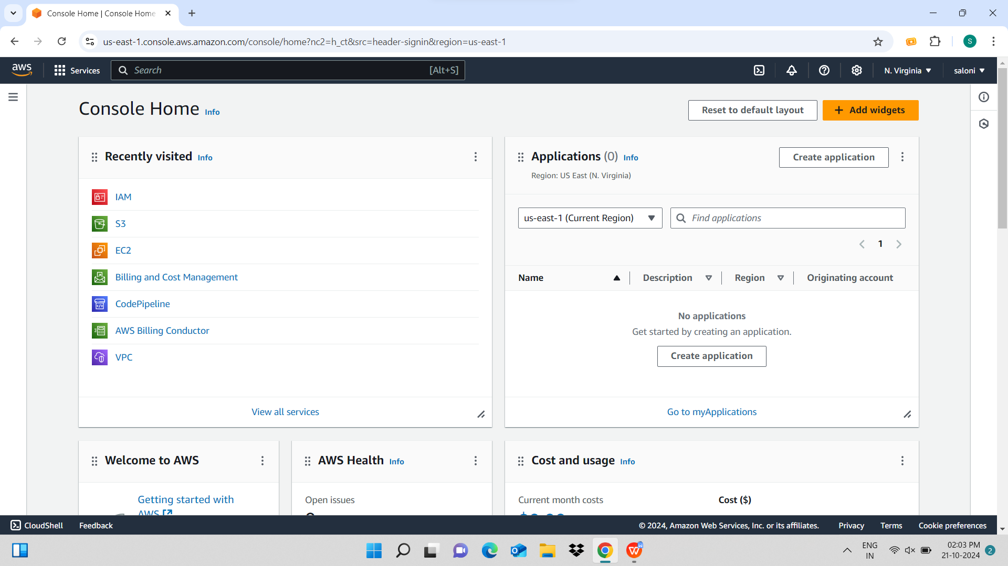

**Click on create user**

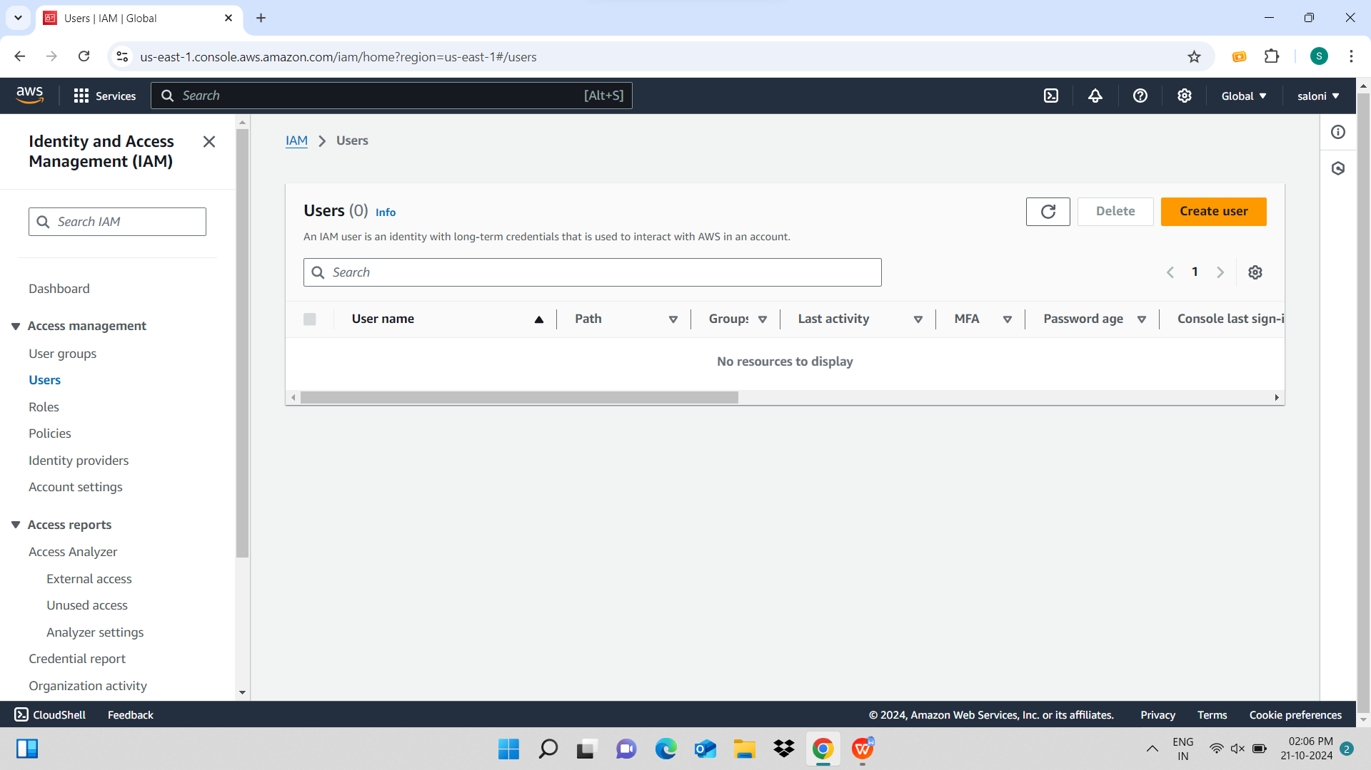

**Now enter the user name and click on next** 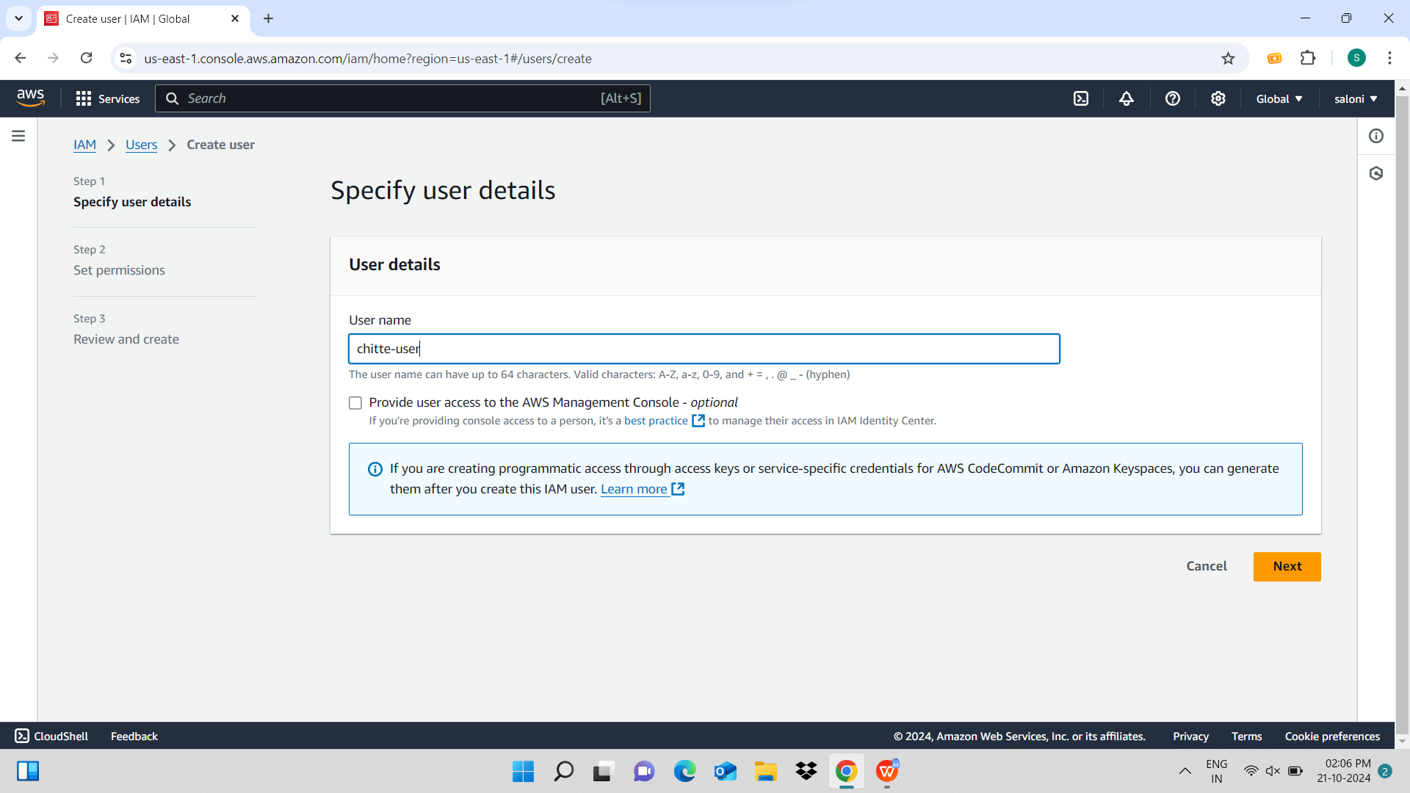

**Now click on attach policies directly and select AmazonEC2FullAccess and Amazon S3 Full access**

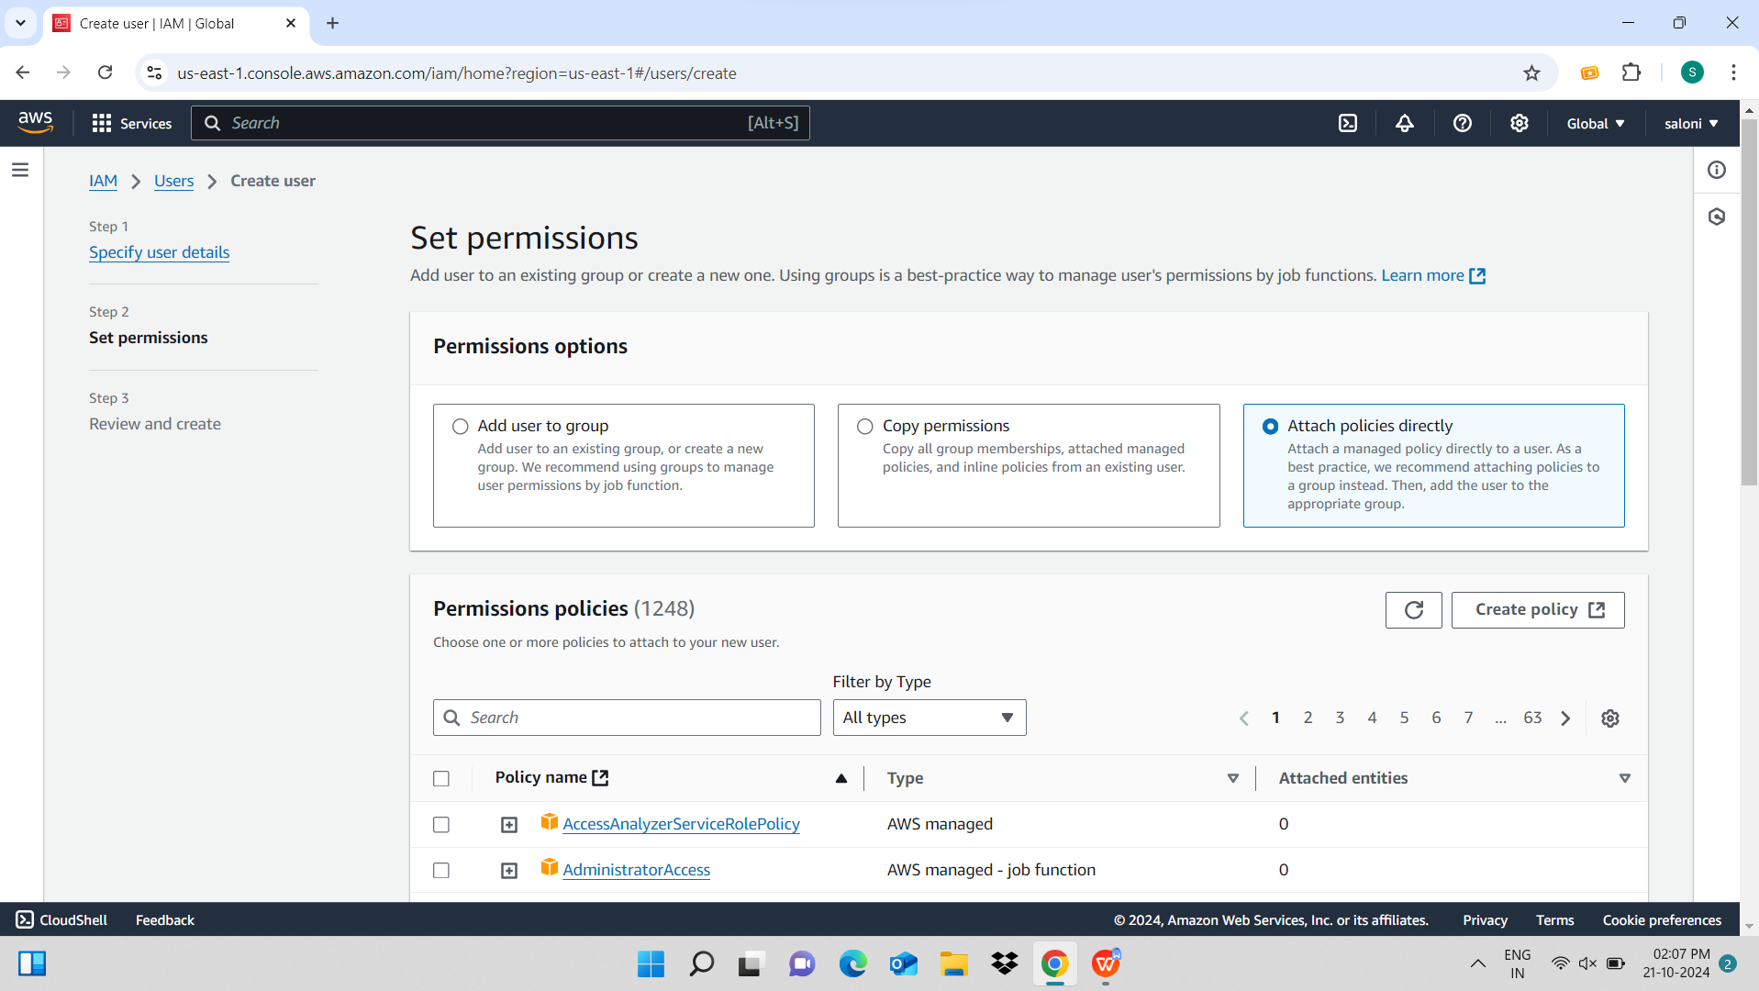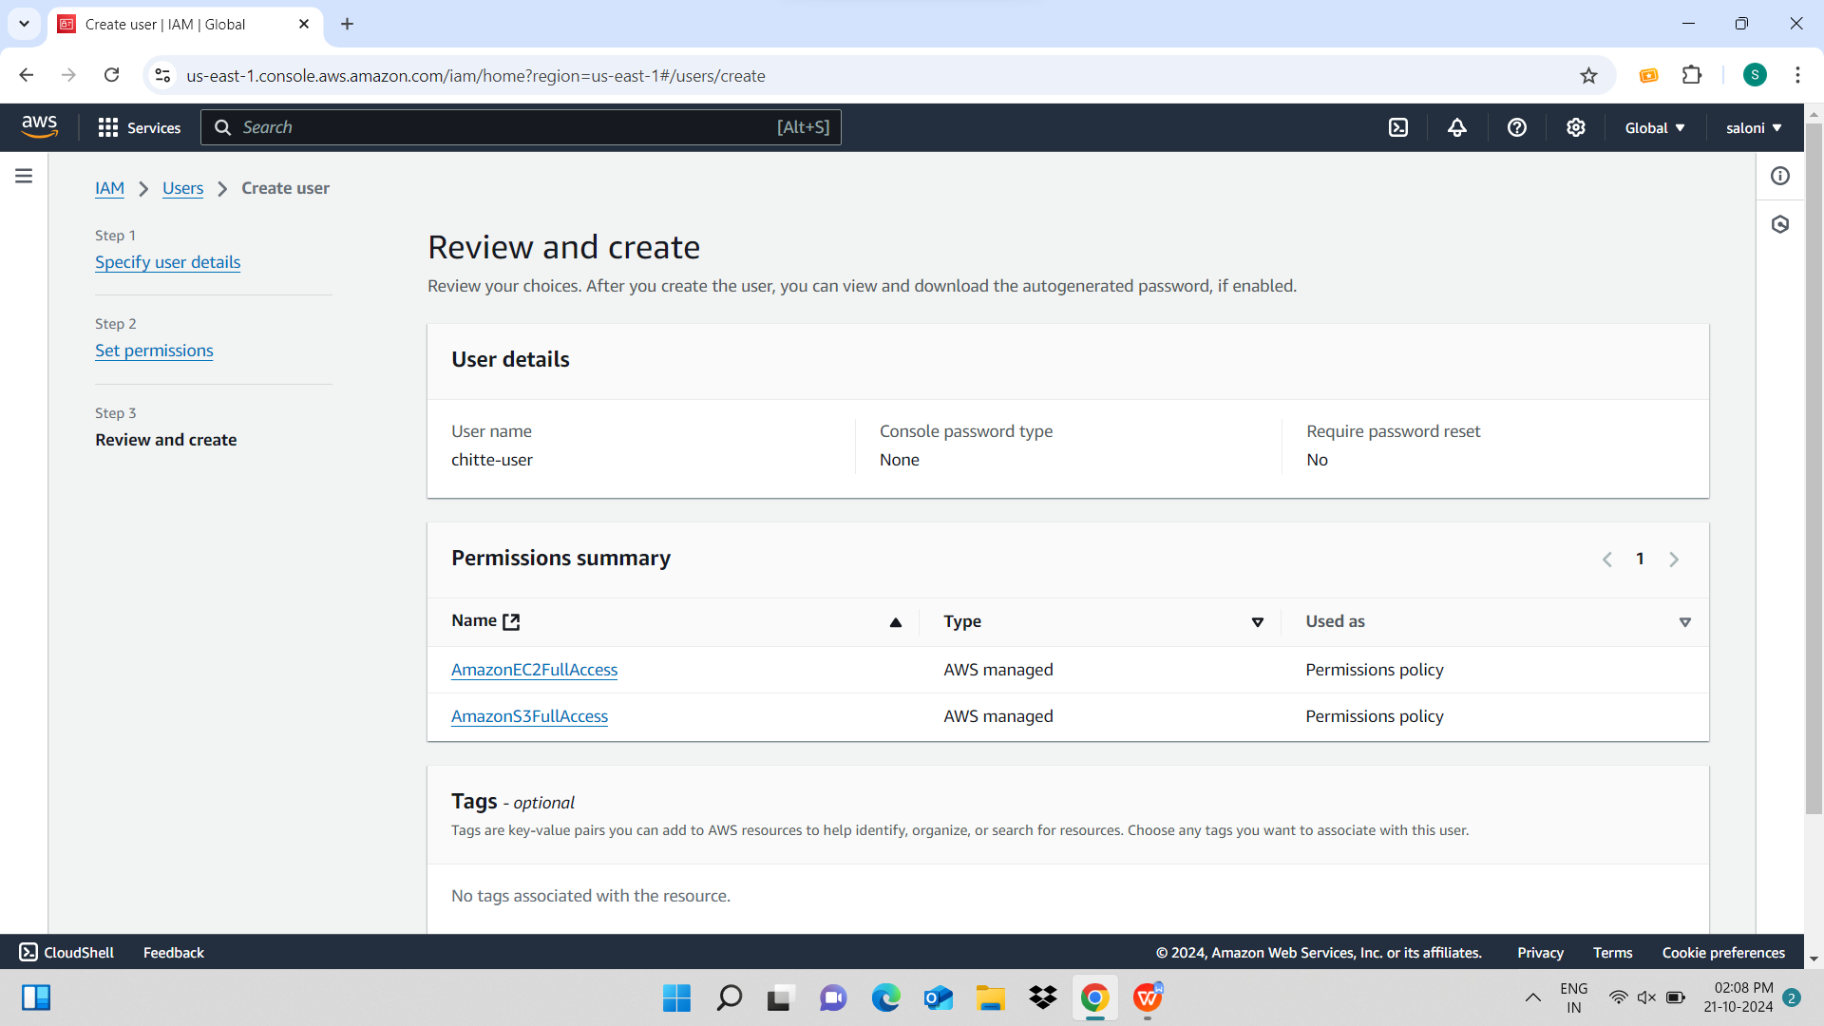

**Now the user has been created successfully**

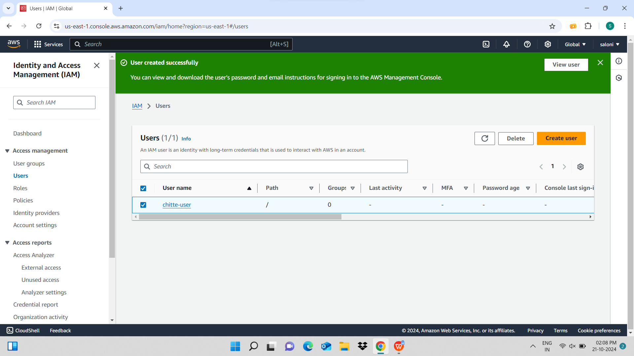

**Here click on enable console access and and download the .csv file**

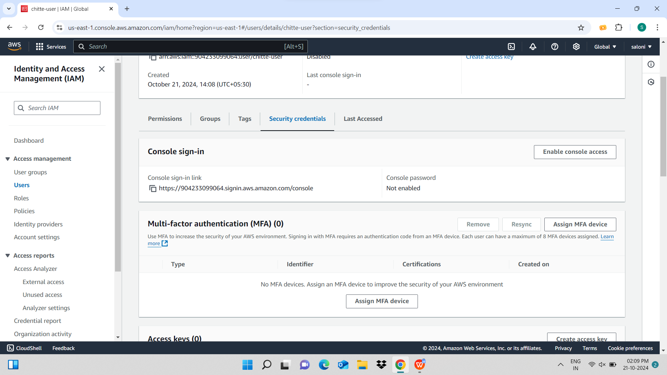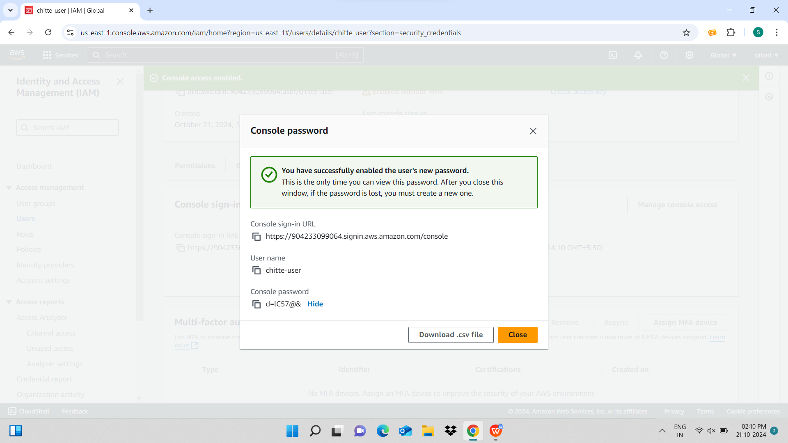

**Here click on create access key and again download the .csv file** 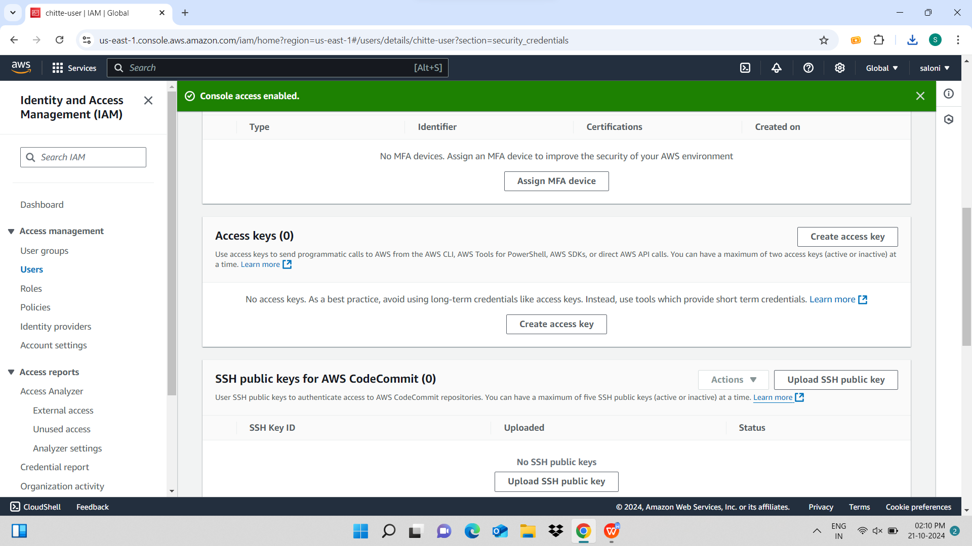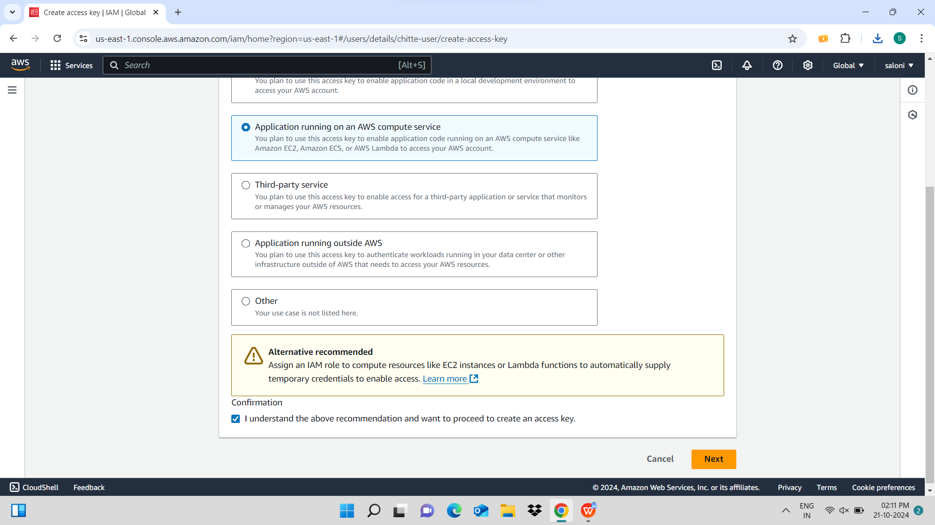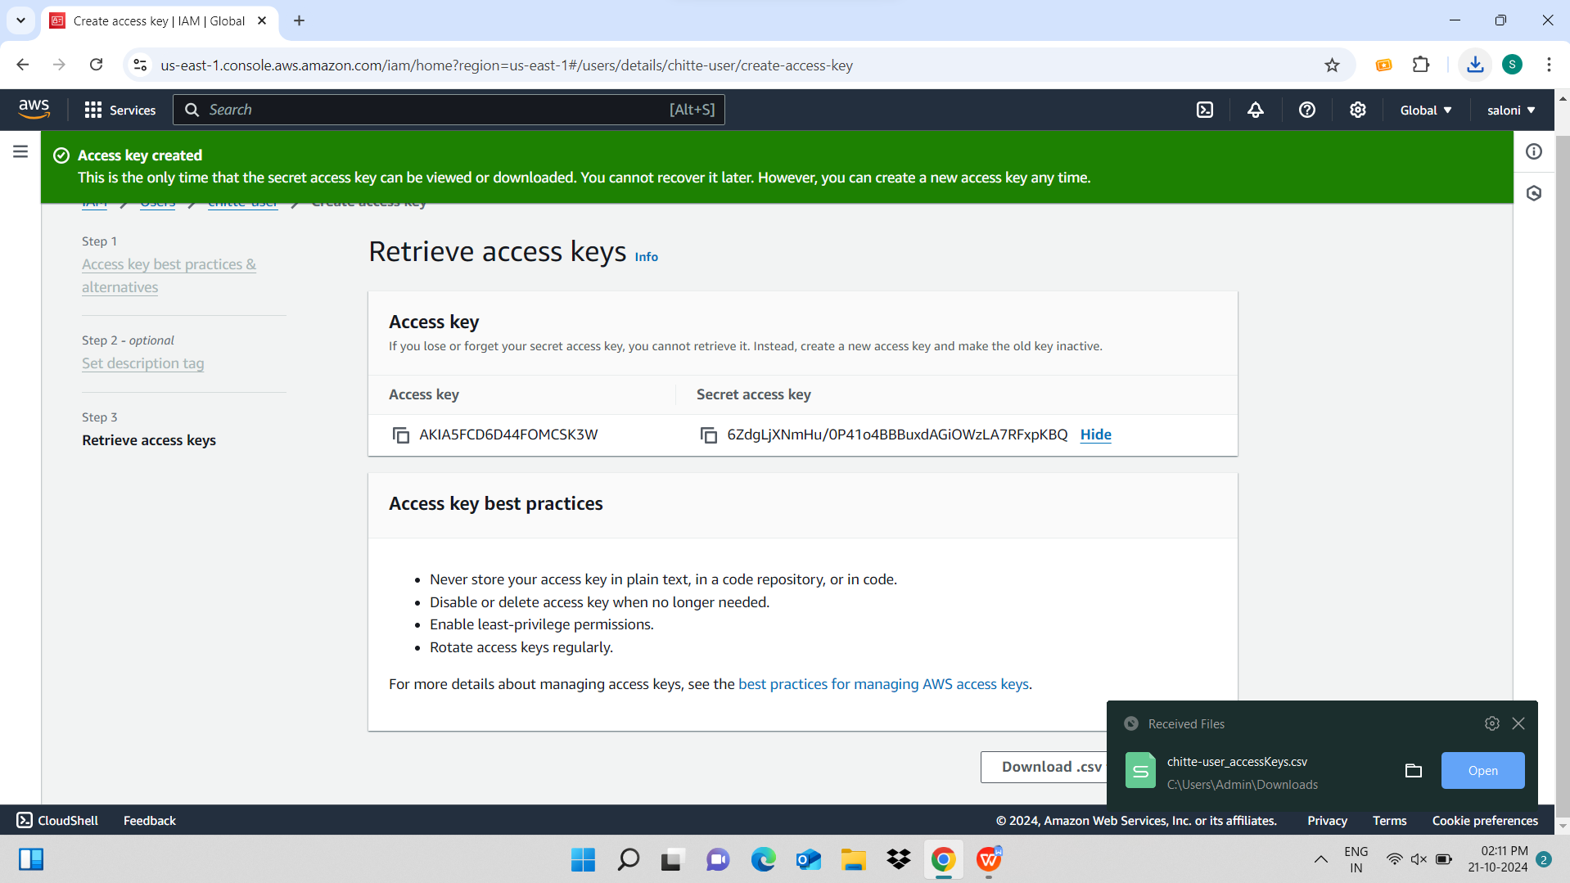

**Here I have created an instance so click on launch instance**

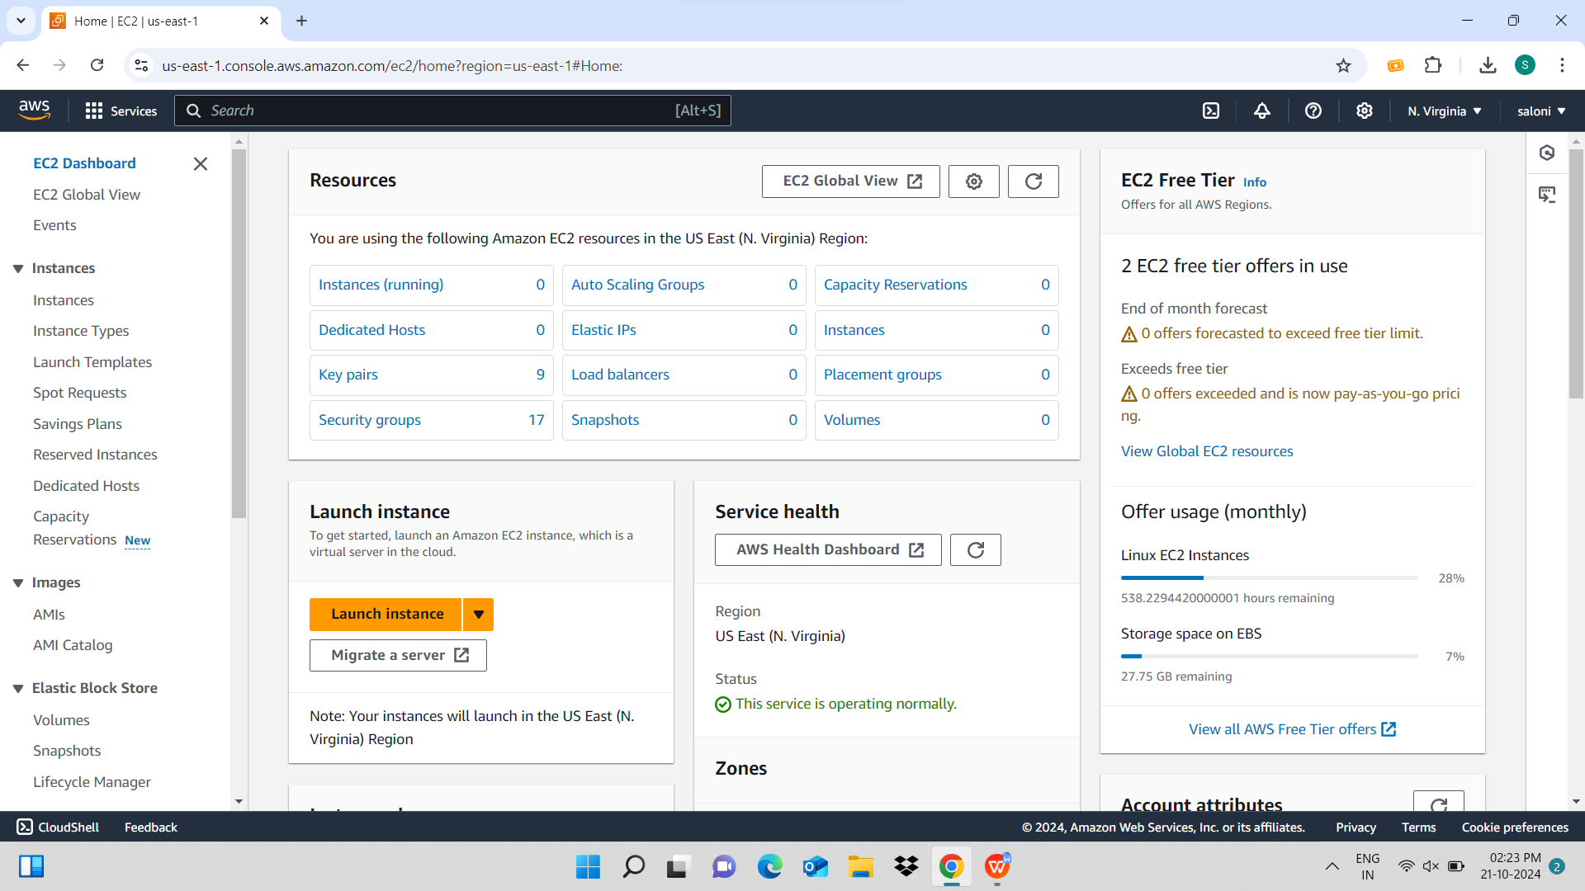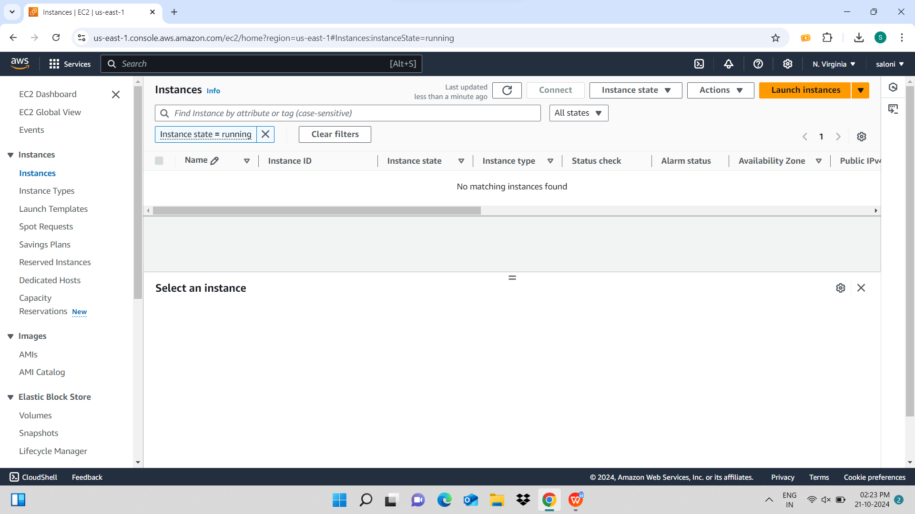

**I**

**I**

**I**

**I have given “instance1” as name of my instance** 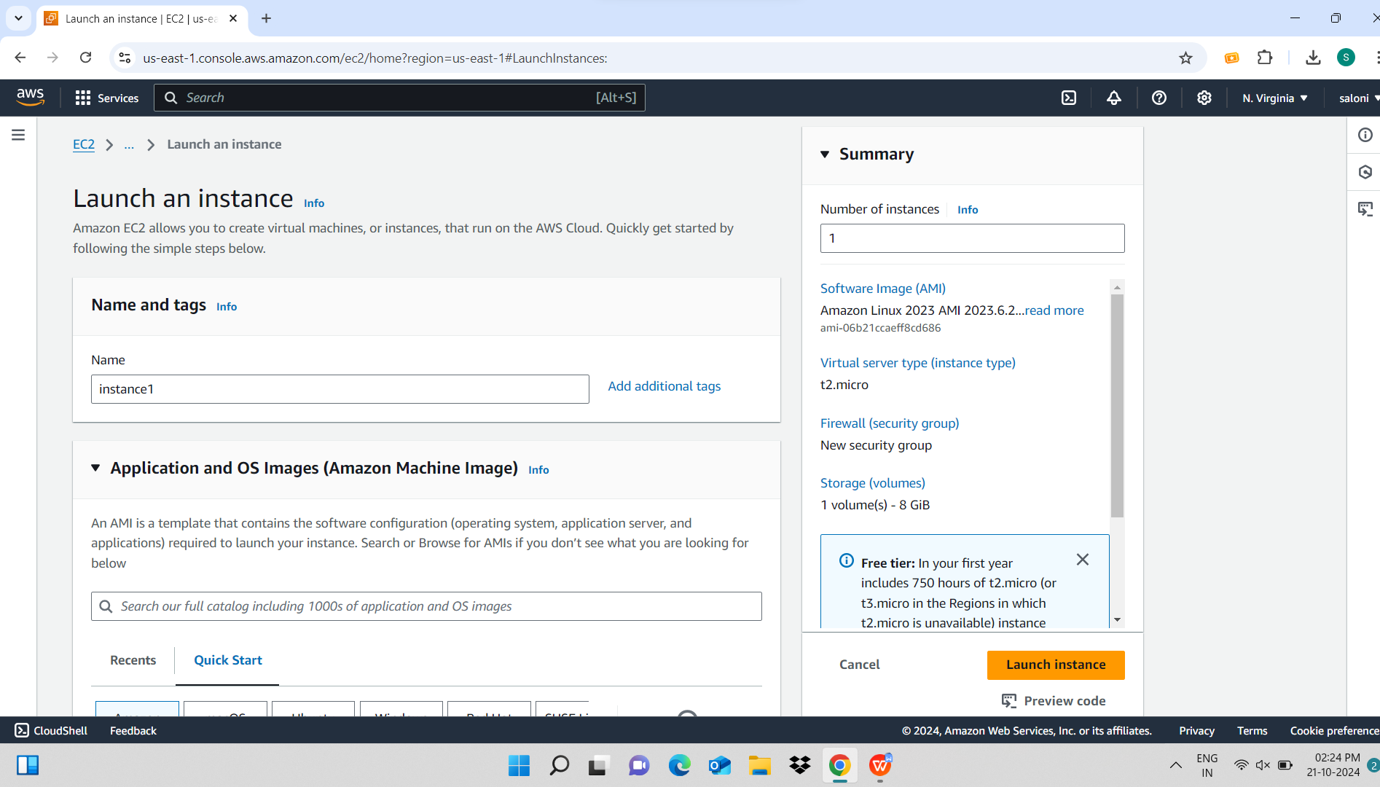

**I have selected a key of name tester-one-s and click on launch instance**

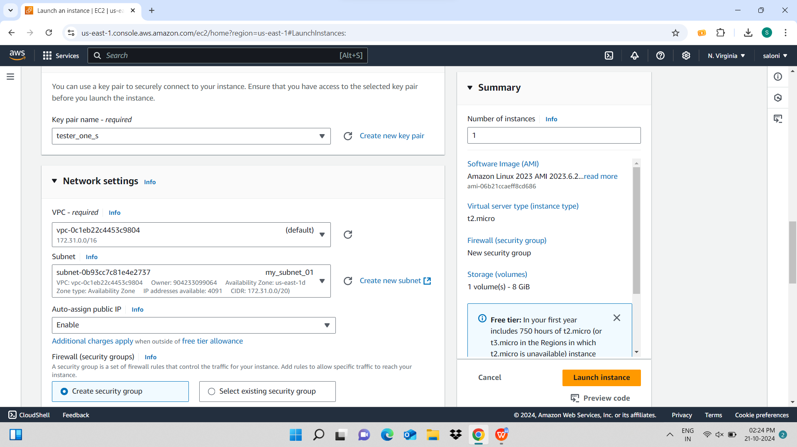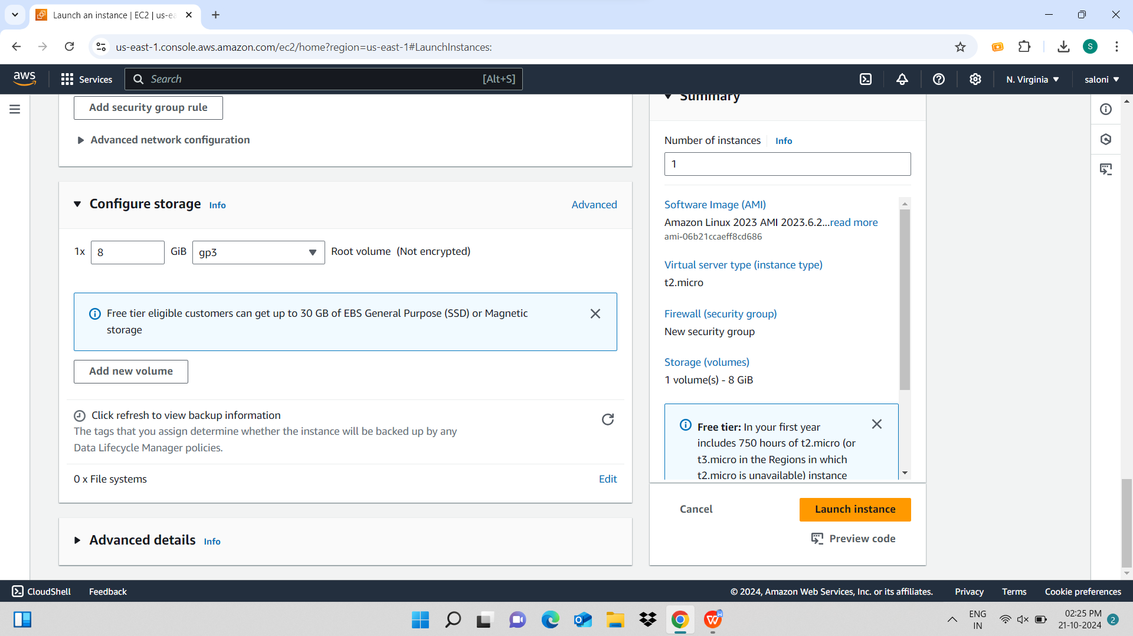

**Now the instance has been created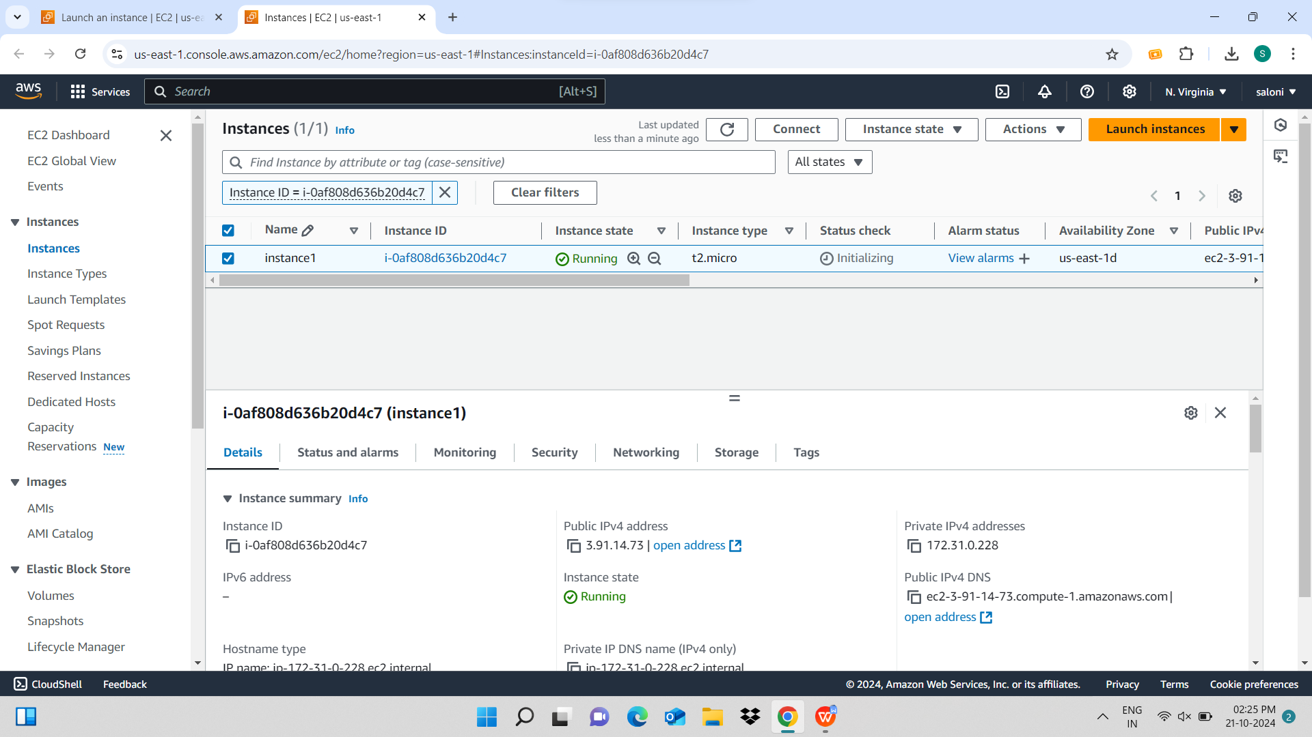Now open the 1st .csv file in that than are user name and password and go on another browser and ;ogin by that given credentials**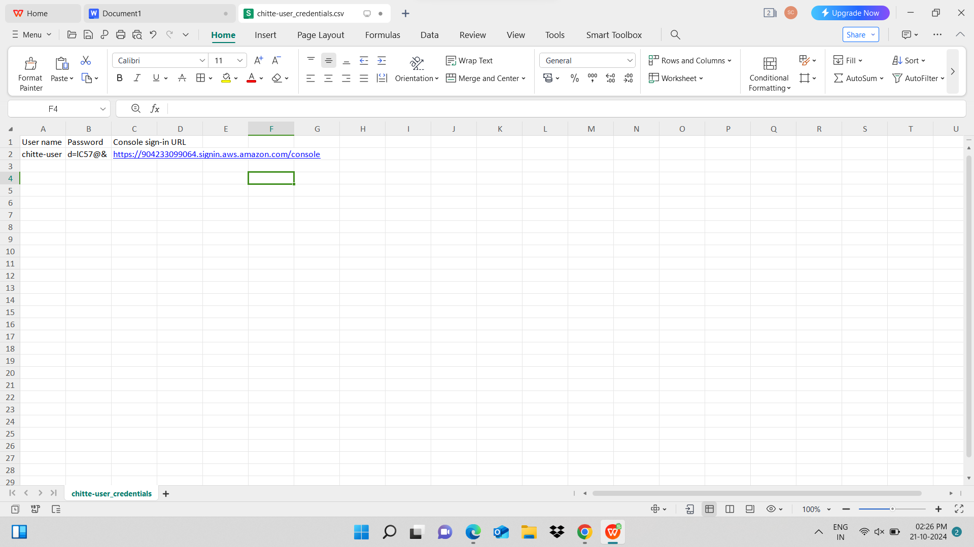

**here I have logged in by than new credentials and the instance which we have created before is visible here so the access is working properly**

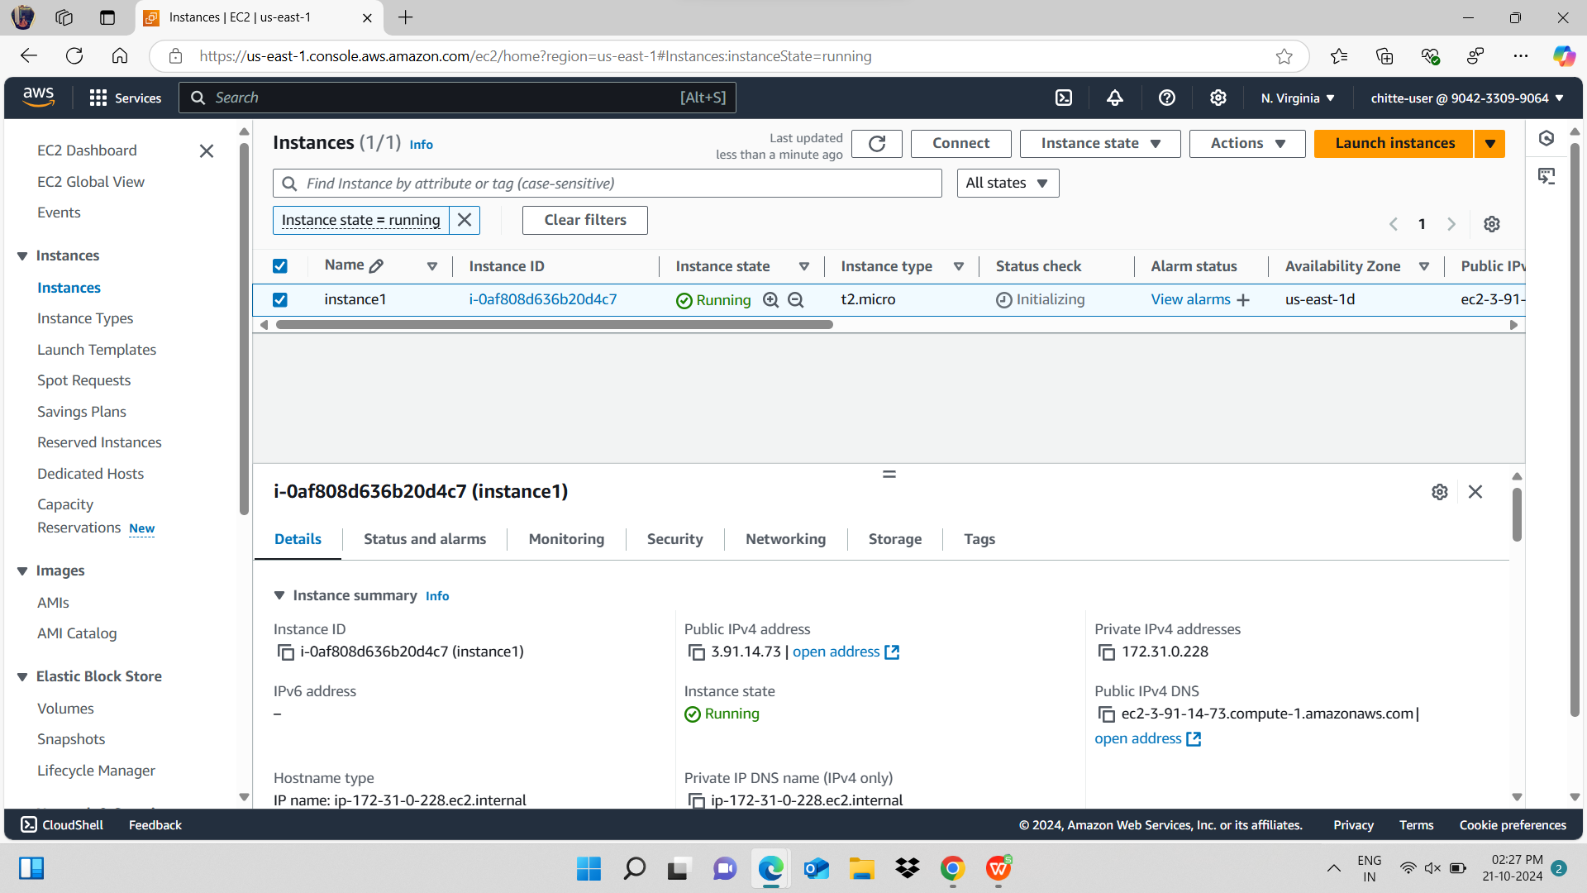**Now I have created a bucket to design a static html file** 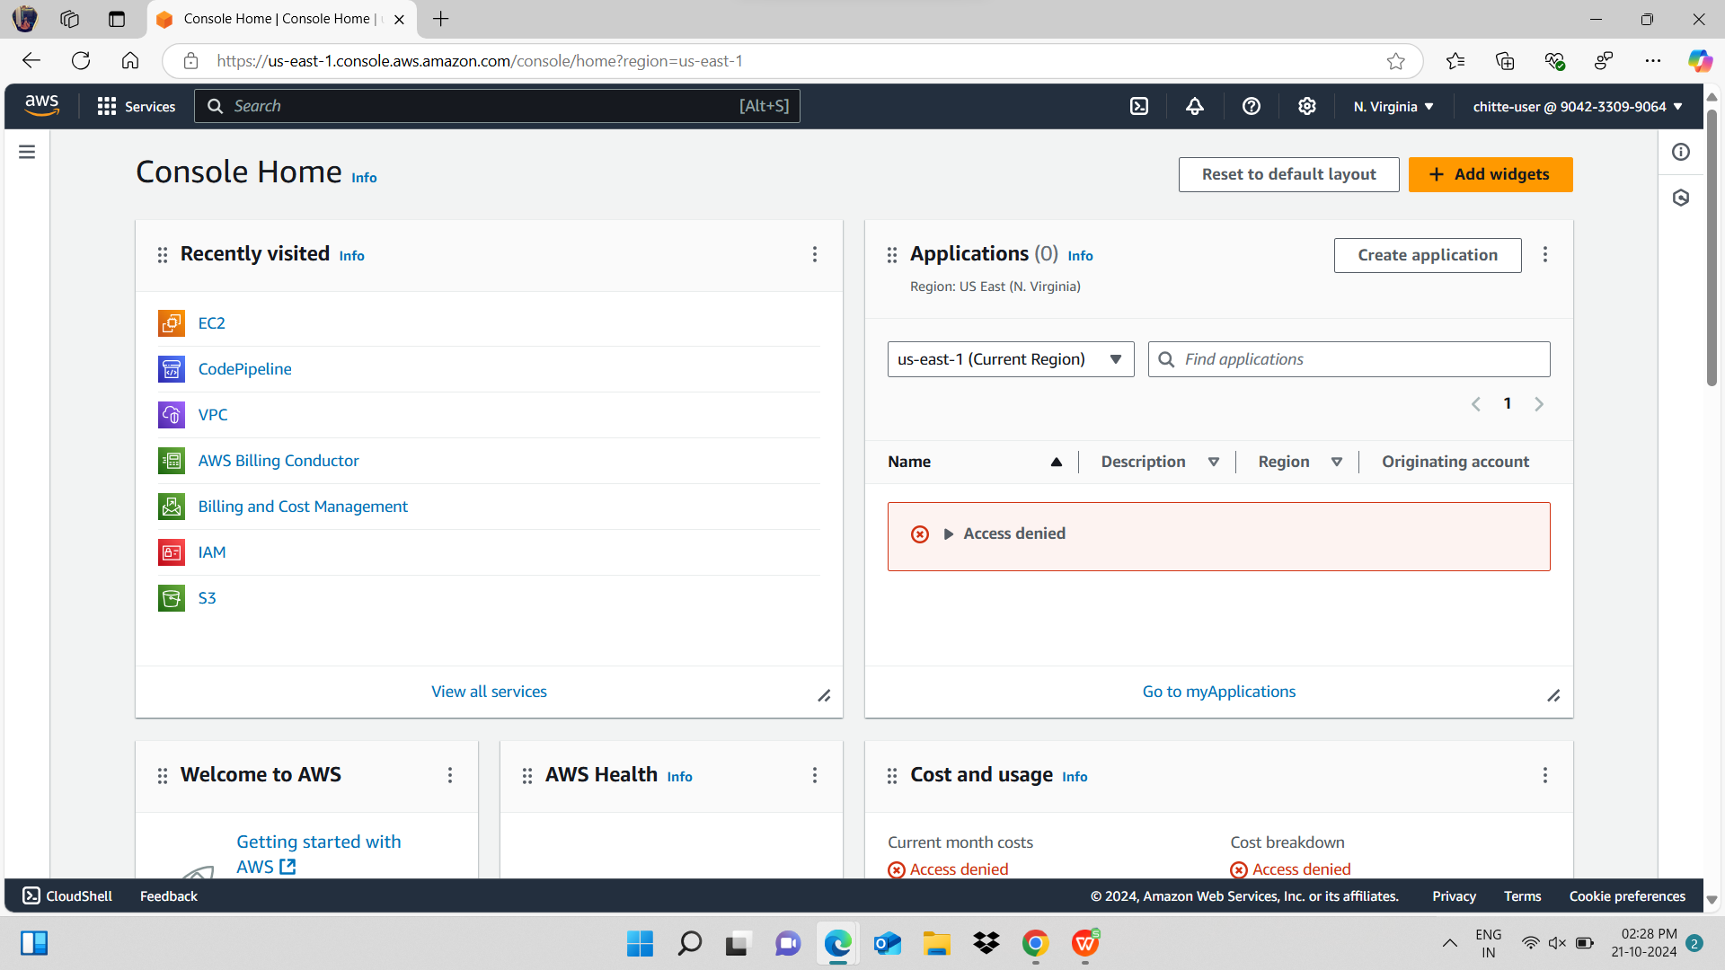

**click on create bucket** 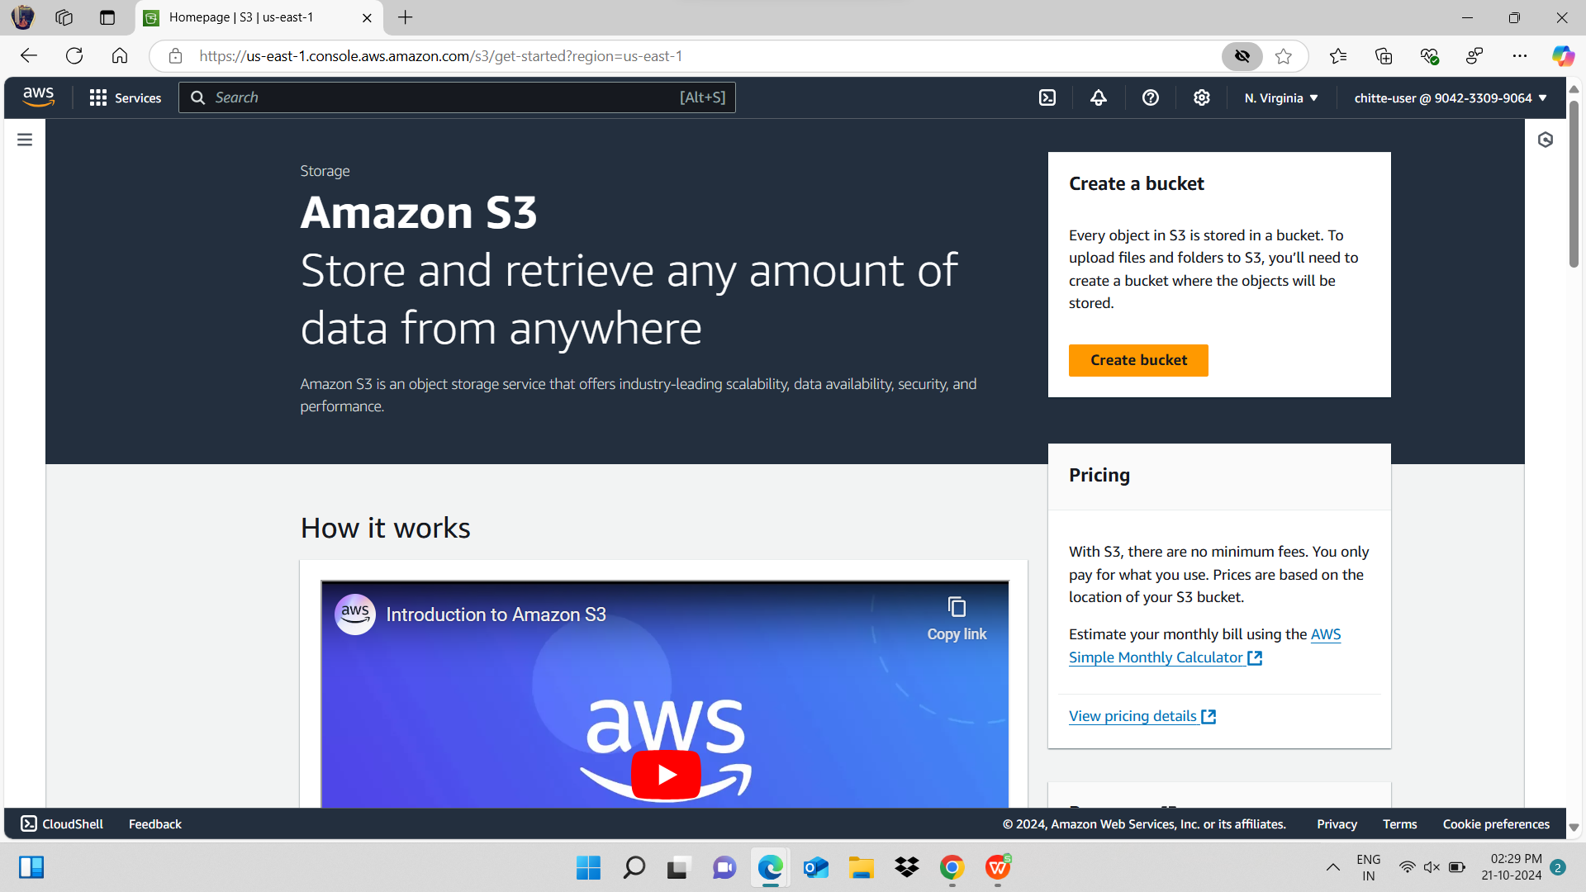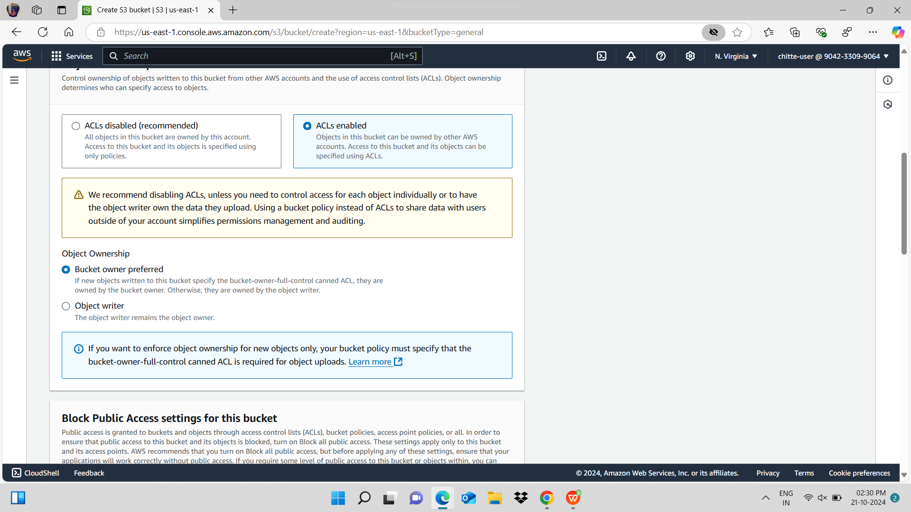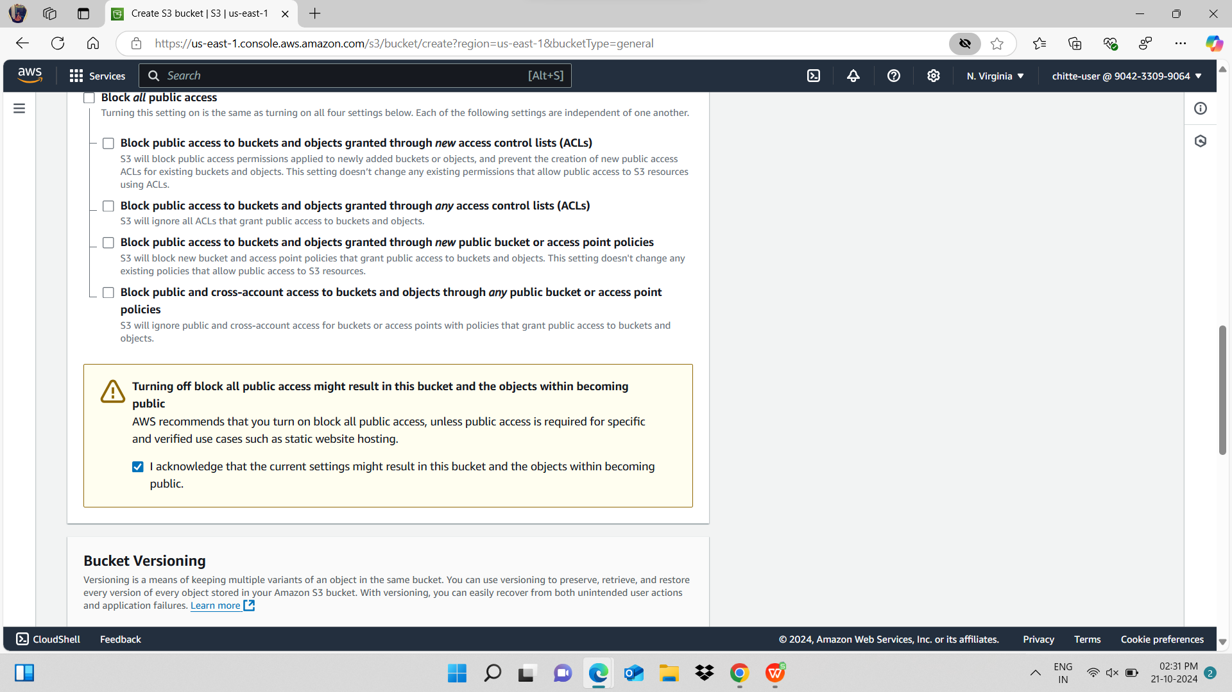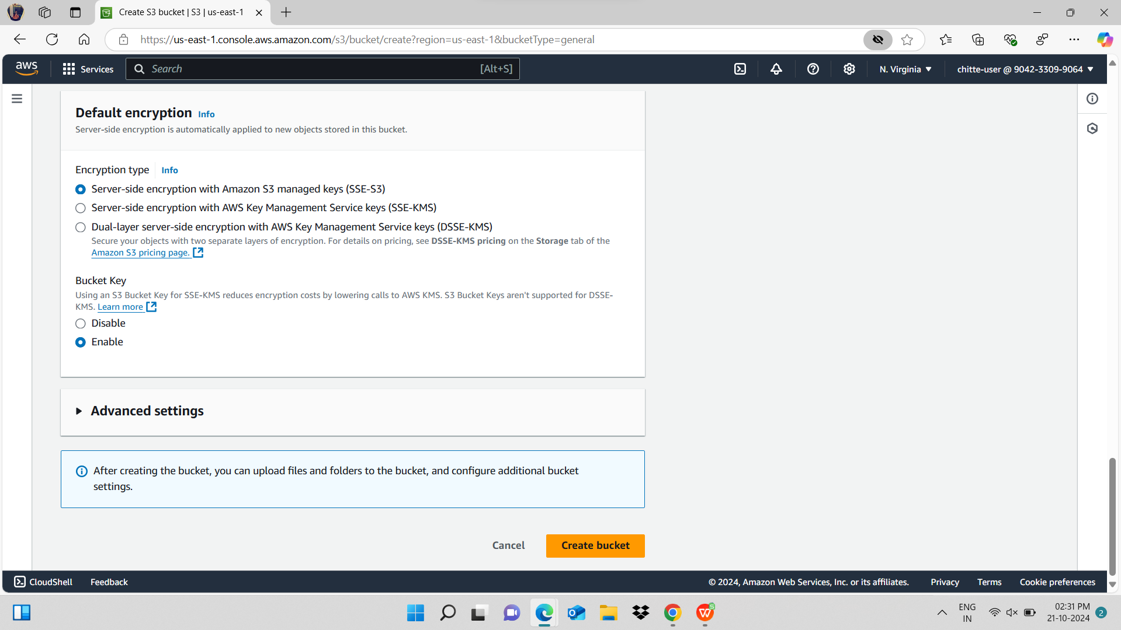

**Bucket has been created**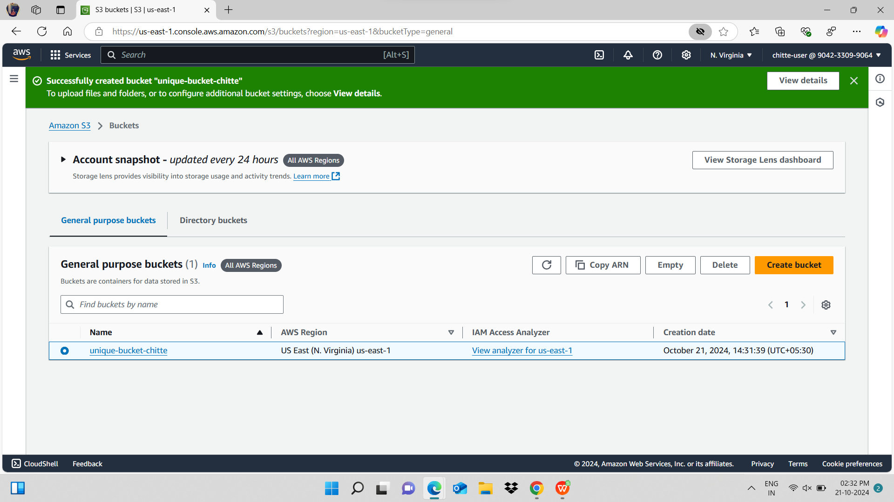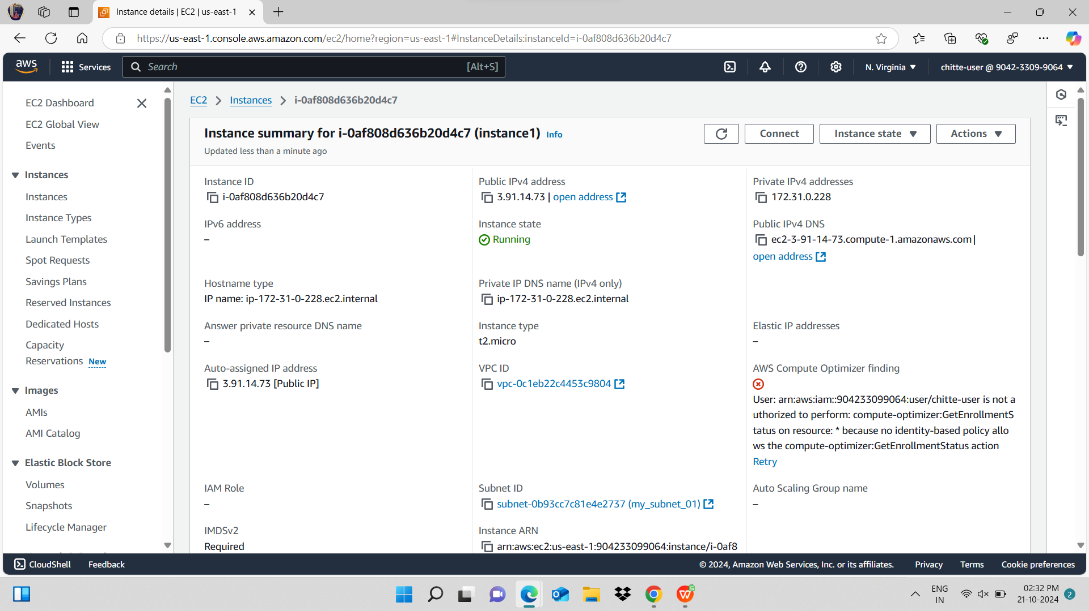

**now for writing the html file I have opened putty and gave the ip and key path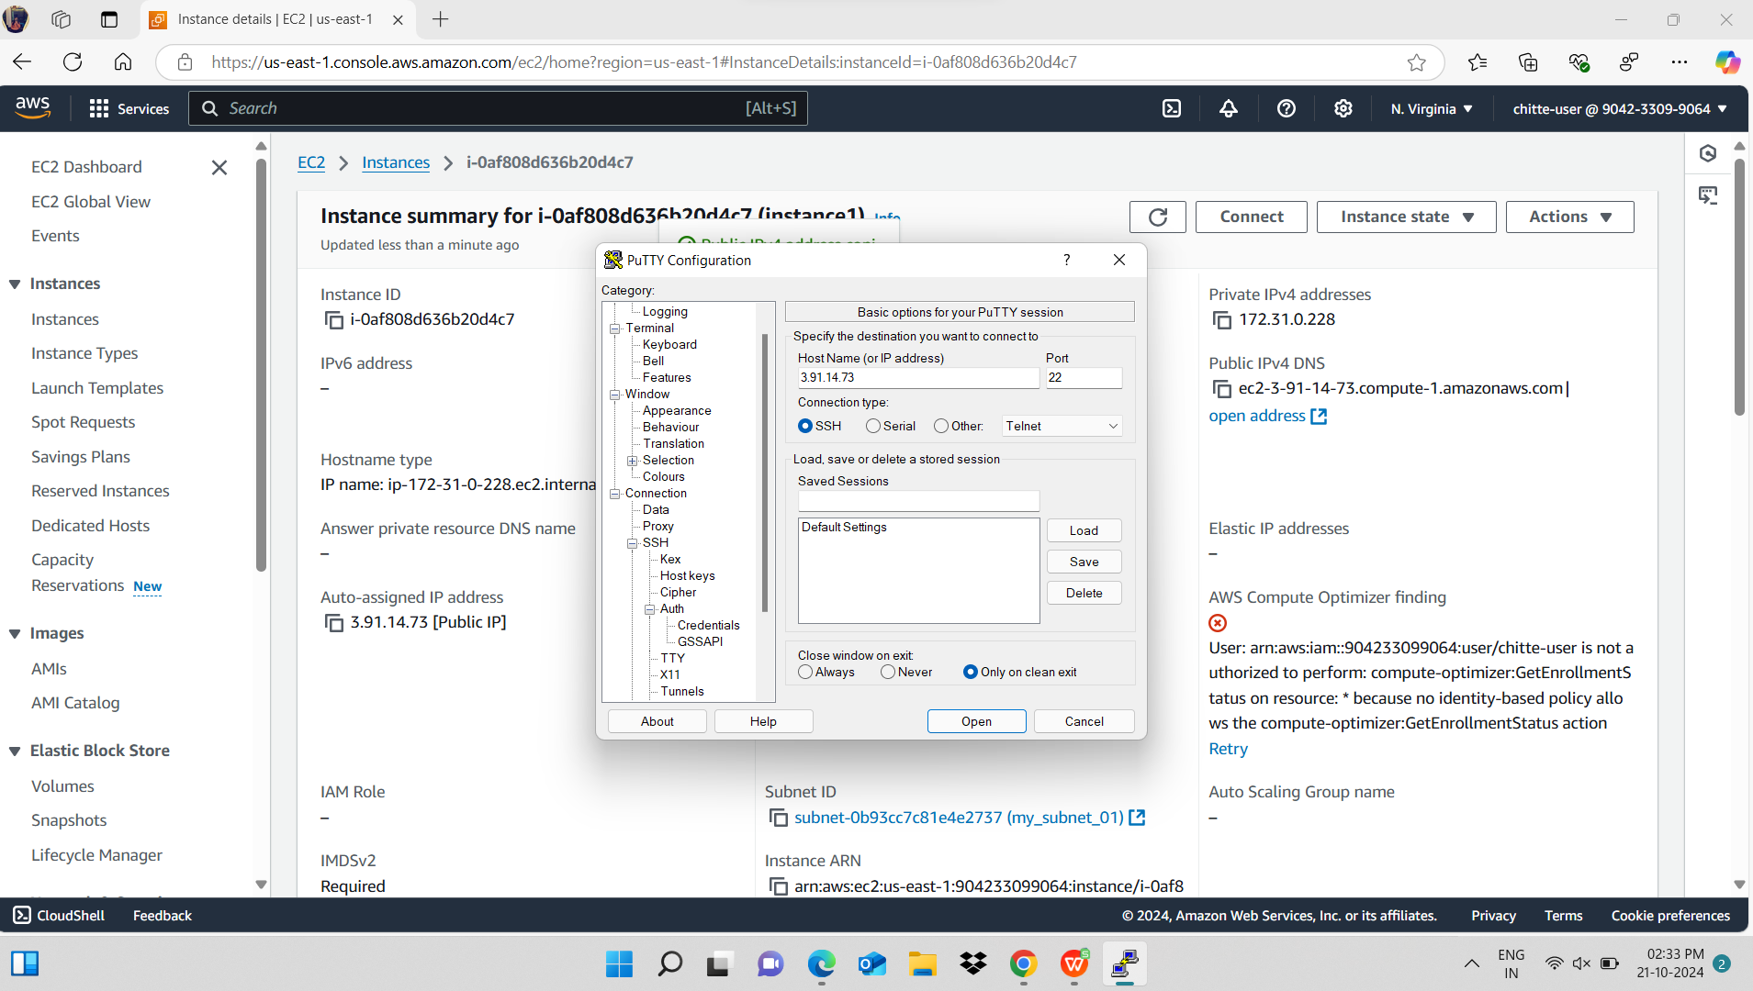This is another csv file**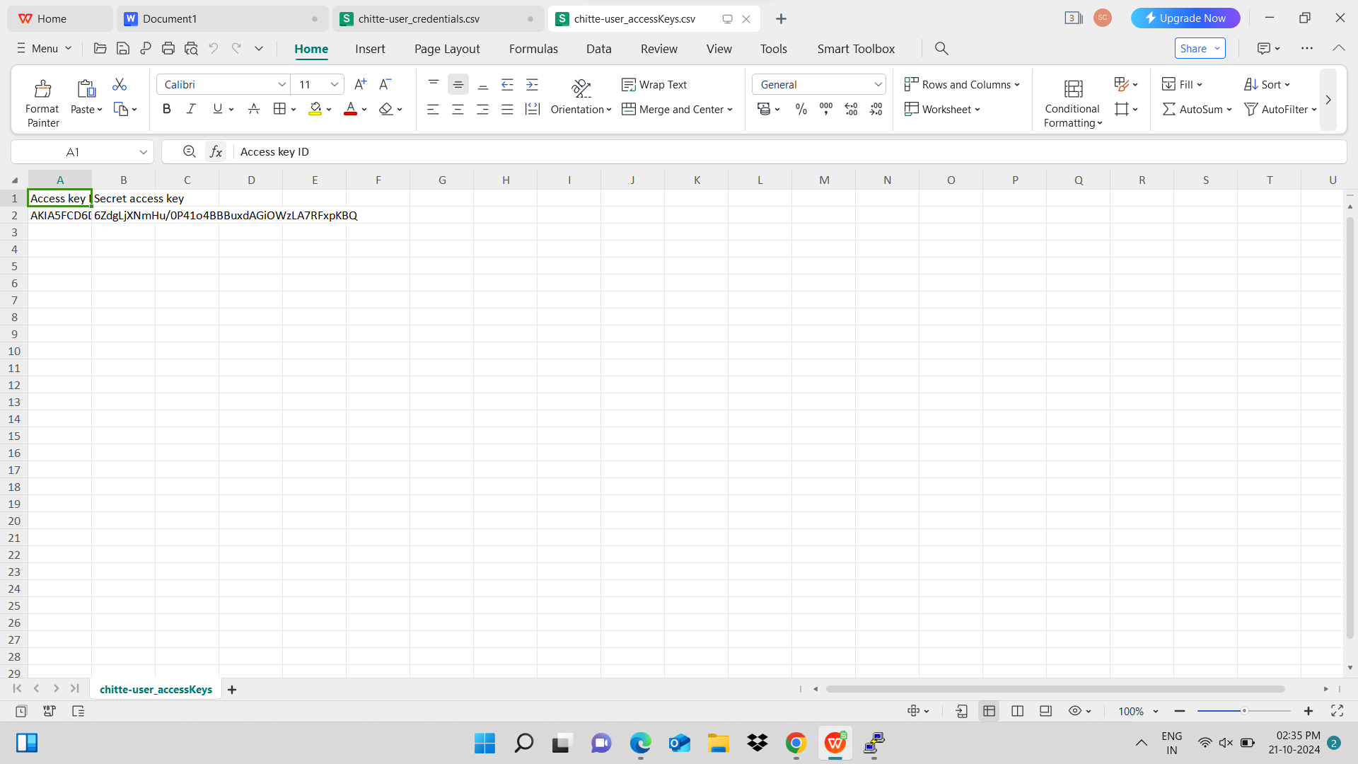

**Here I have eritten all the commands to write html code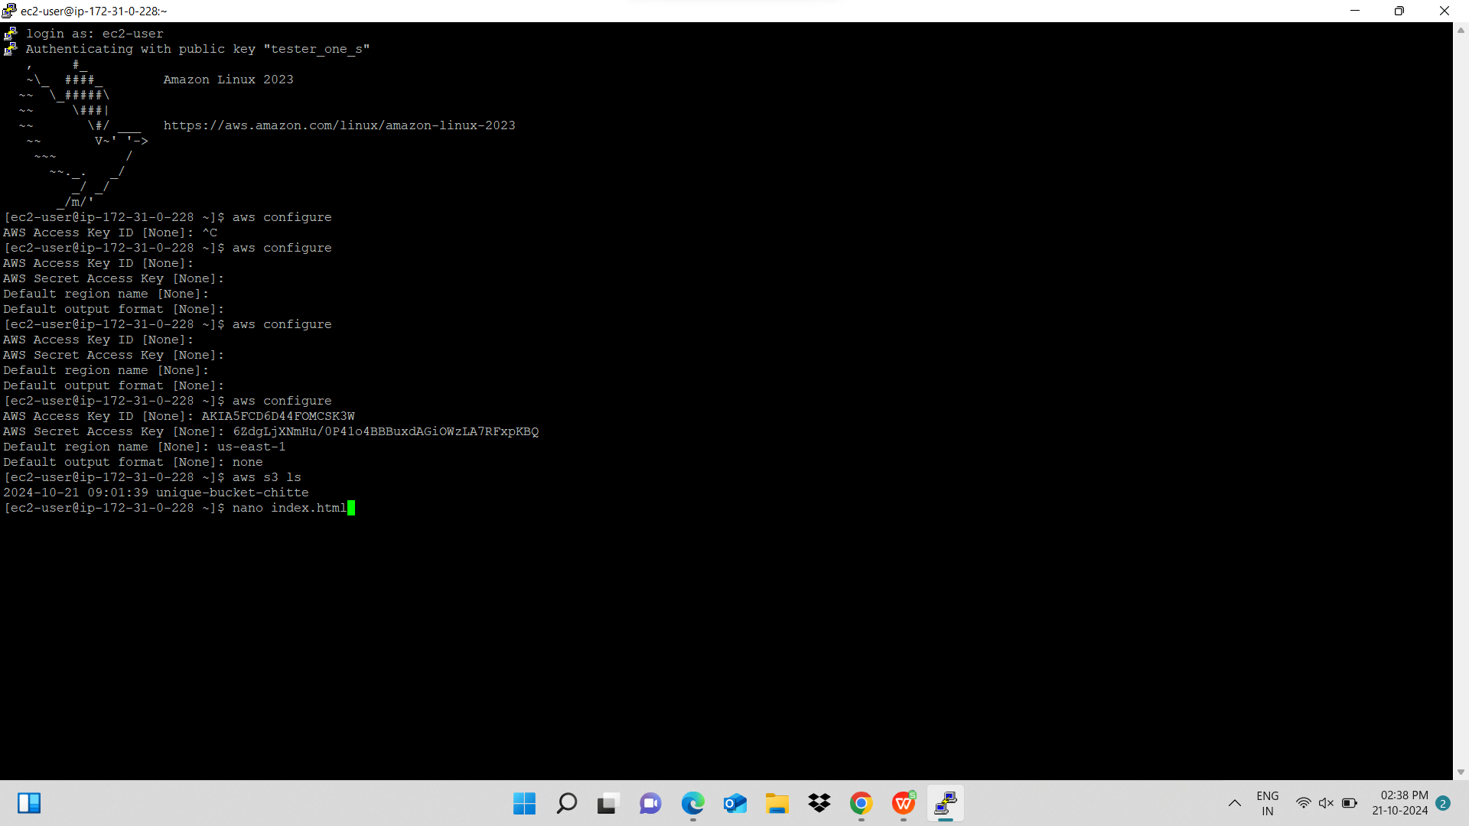This is thehml code for our msg**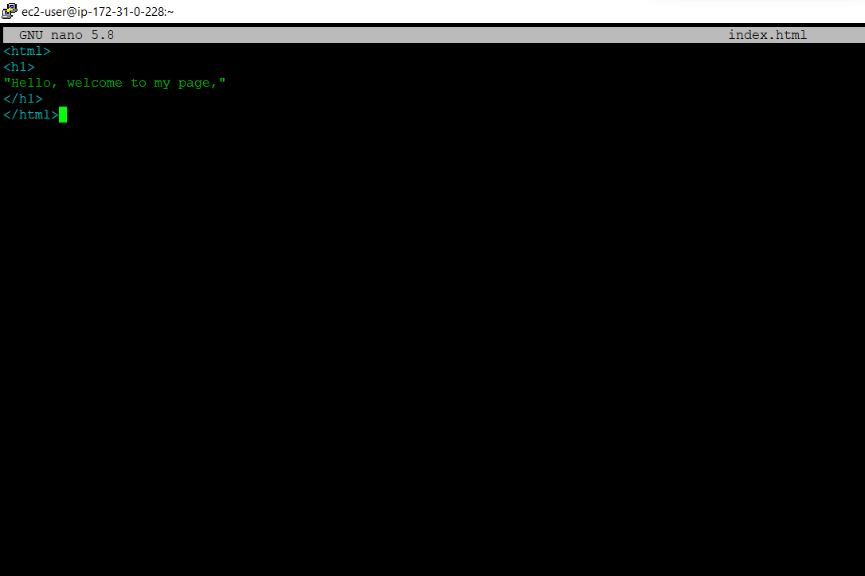

**Here in the last the command is for copy our index.html file into root user**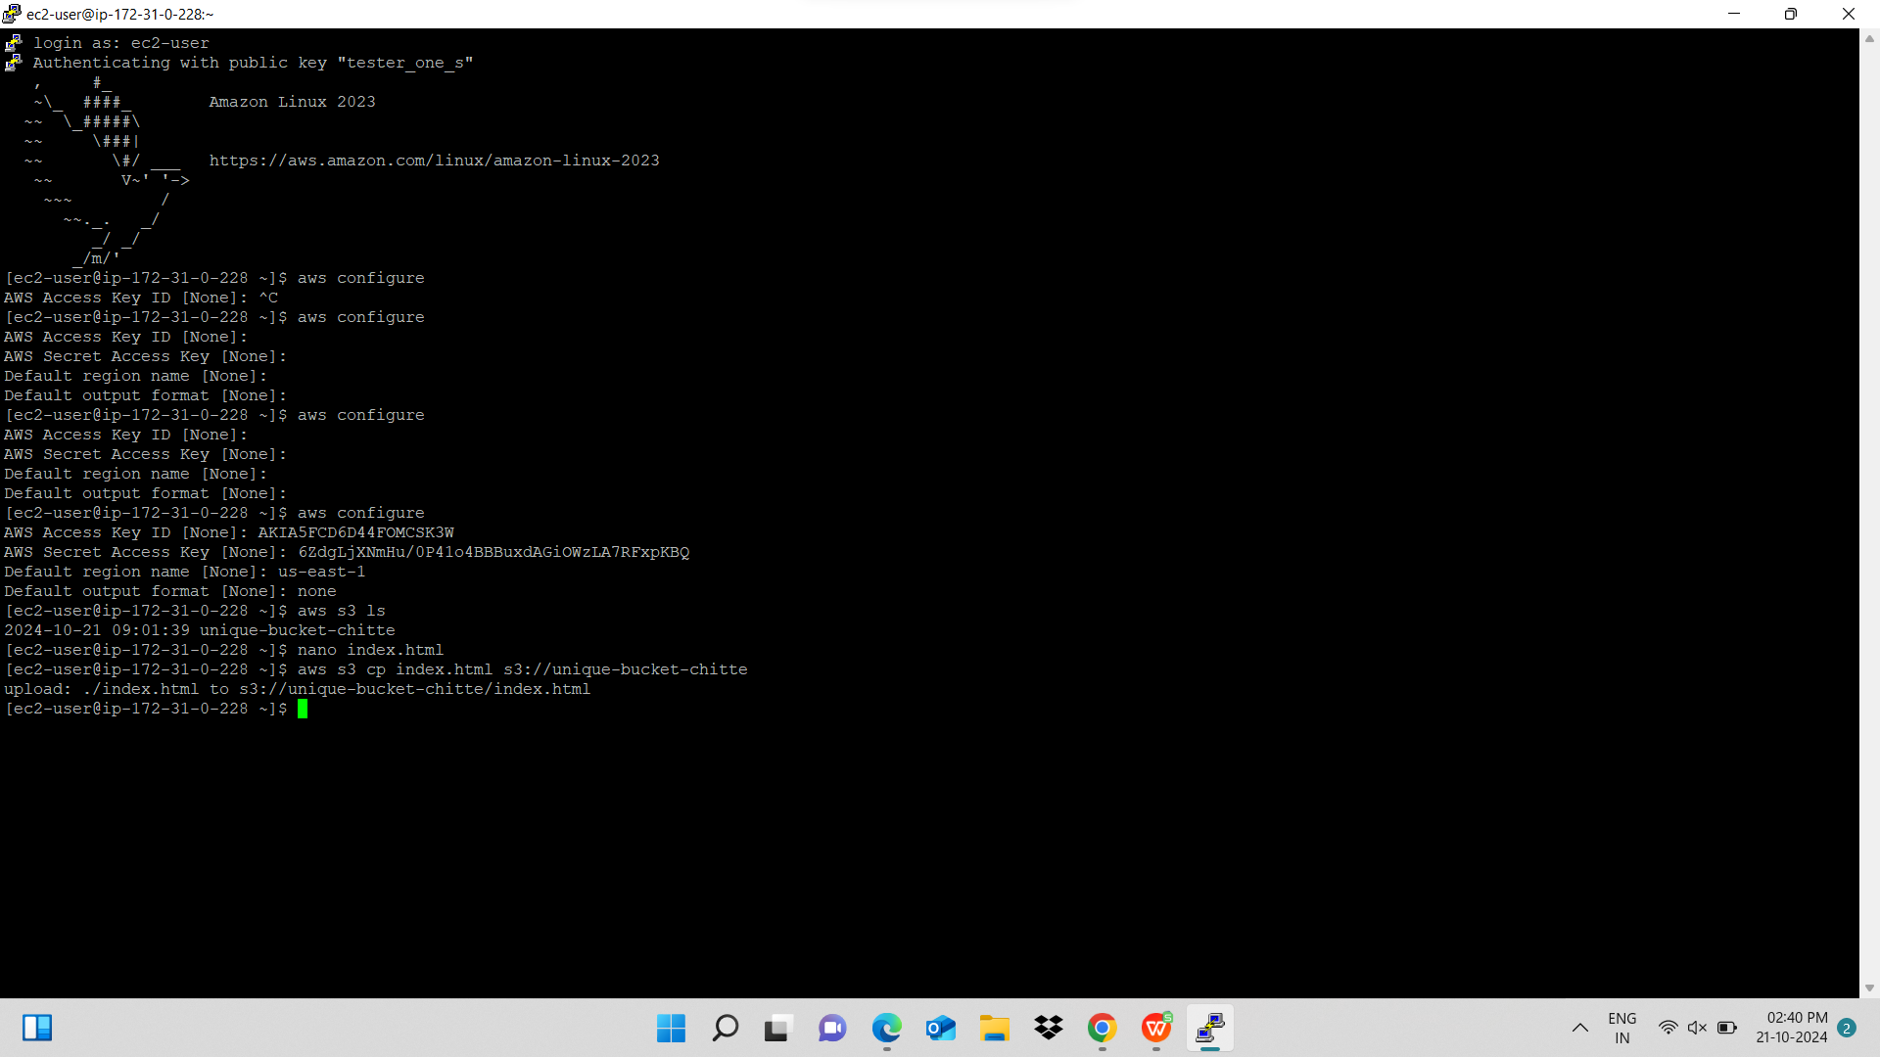

**This is root user and the index.html file is created successfully**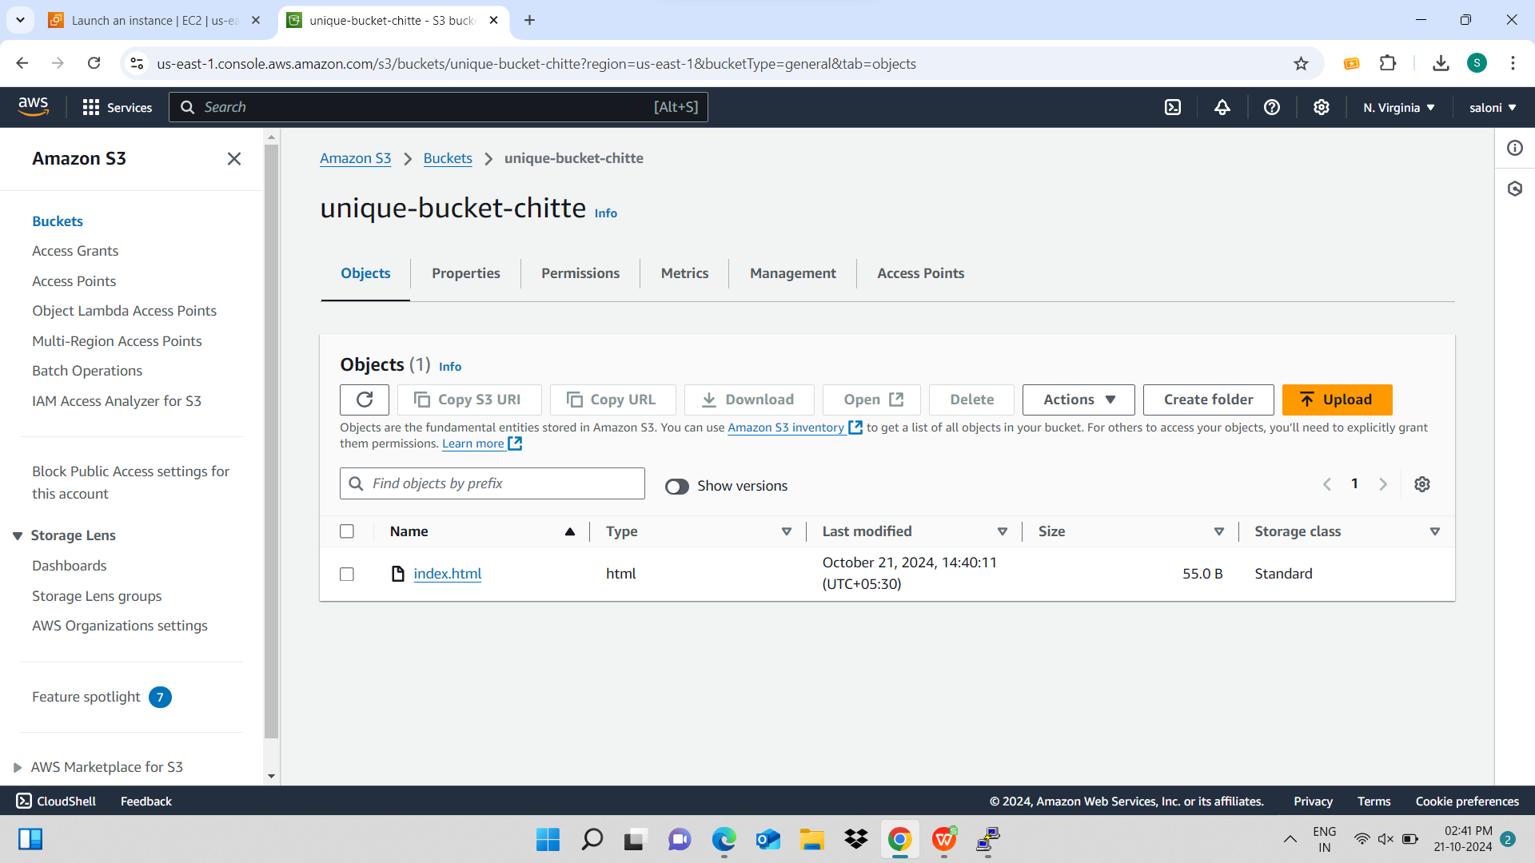

**We can access it through object url**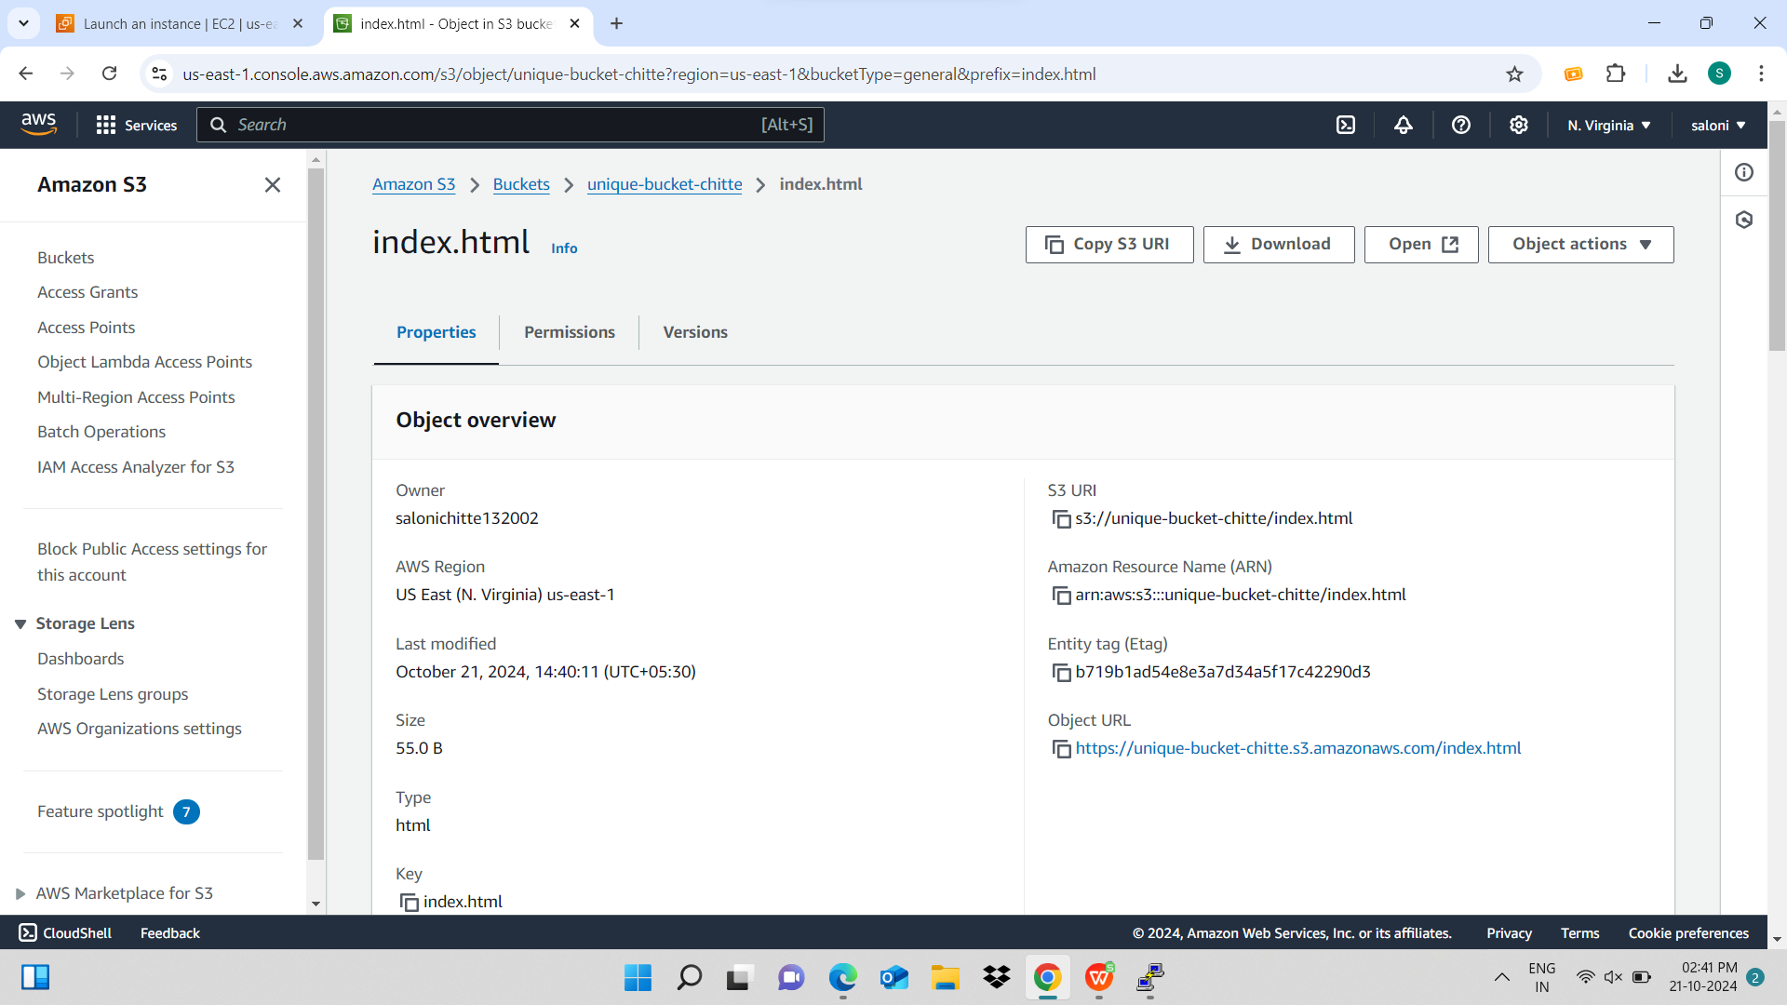

**Here I have given all the permission to access the file publically**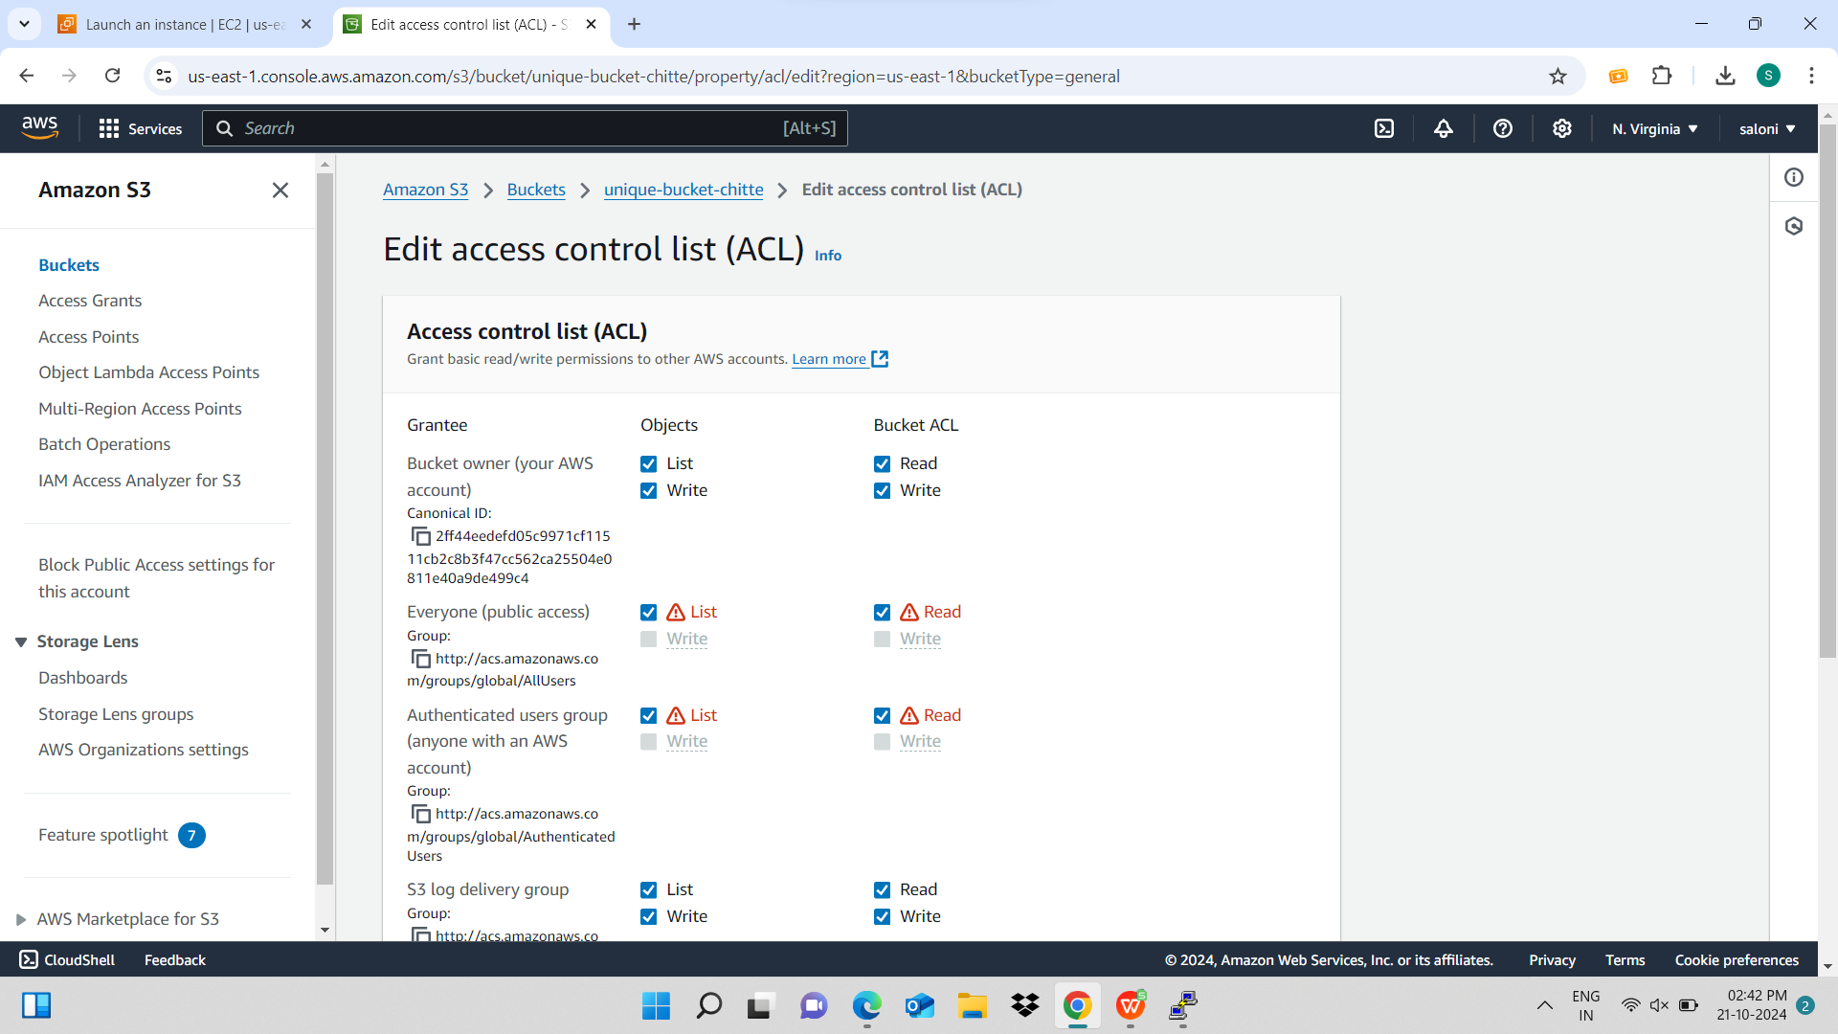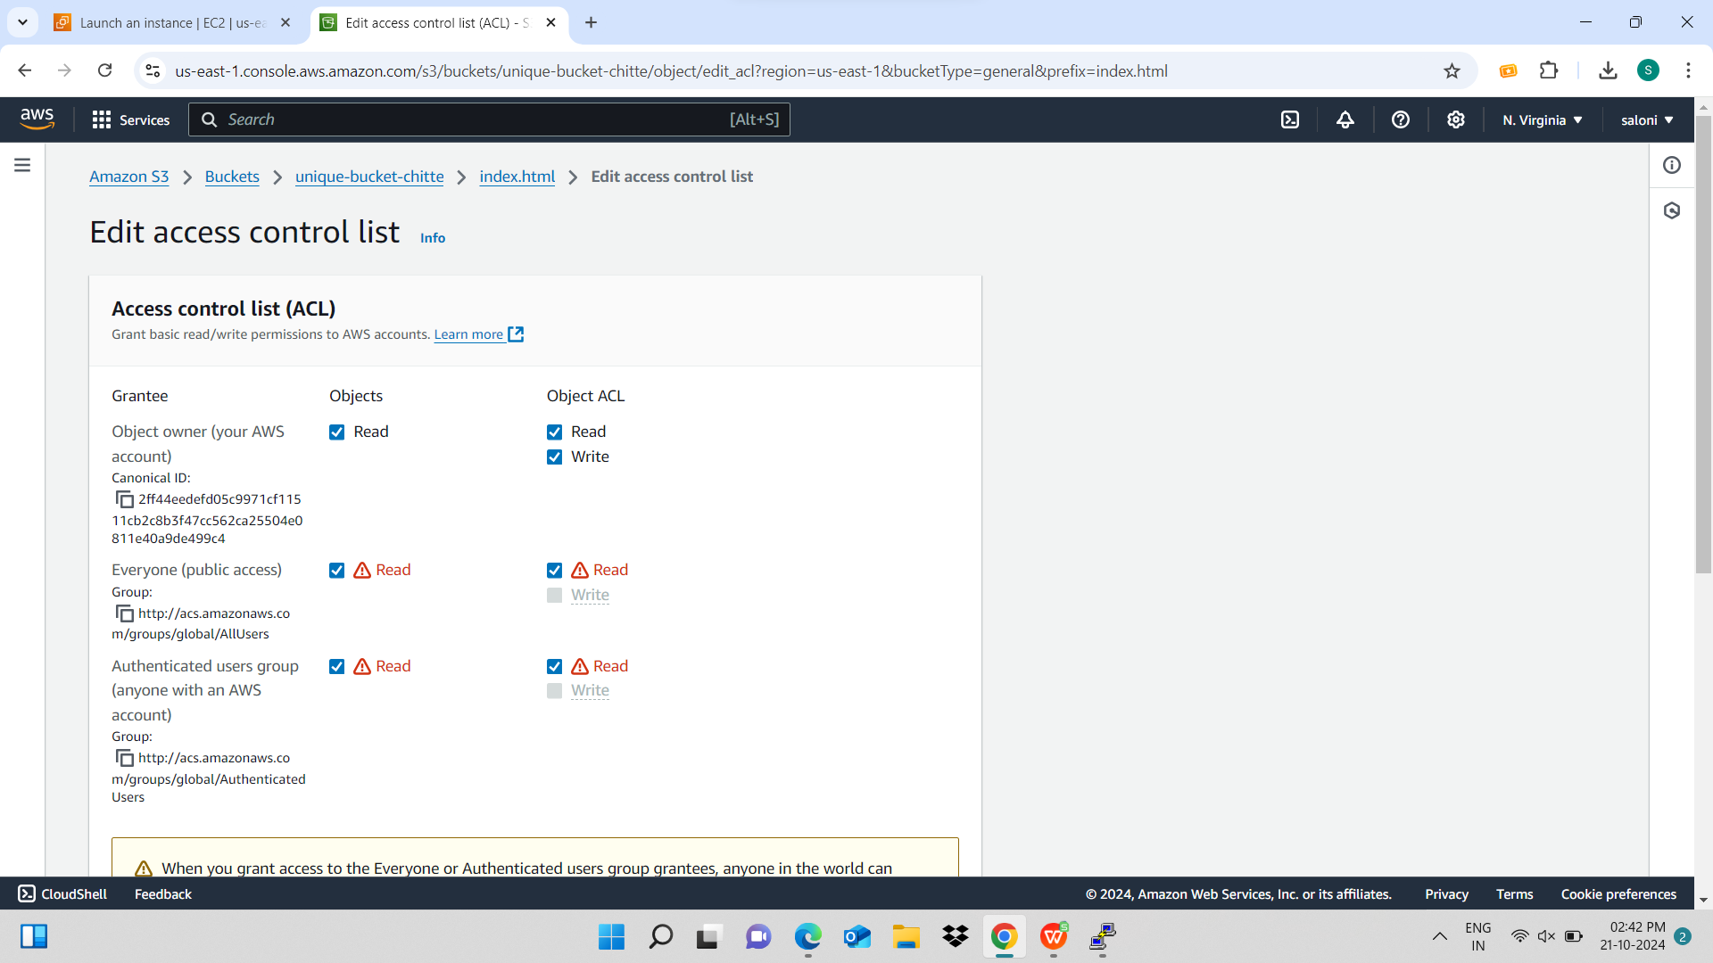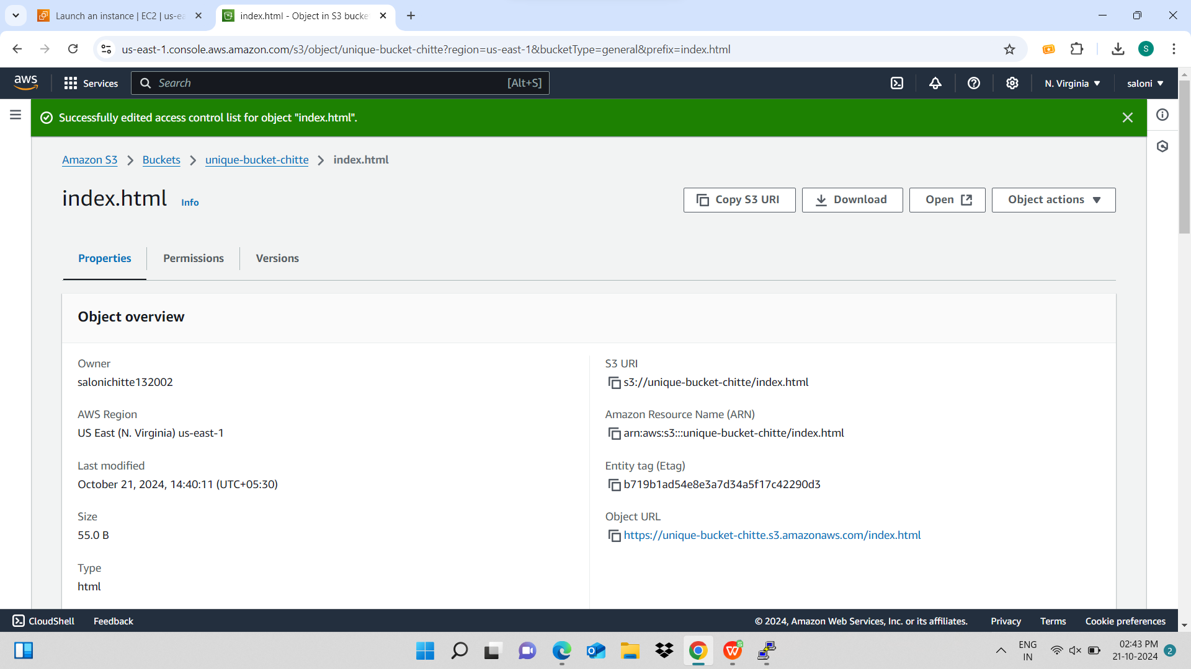

**This is the final output of our html file**

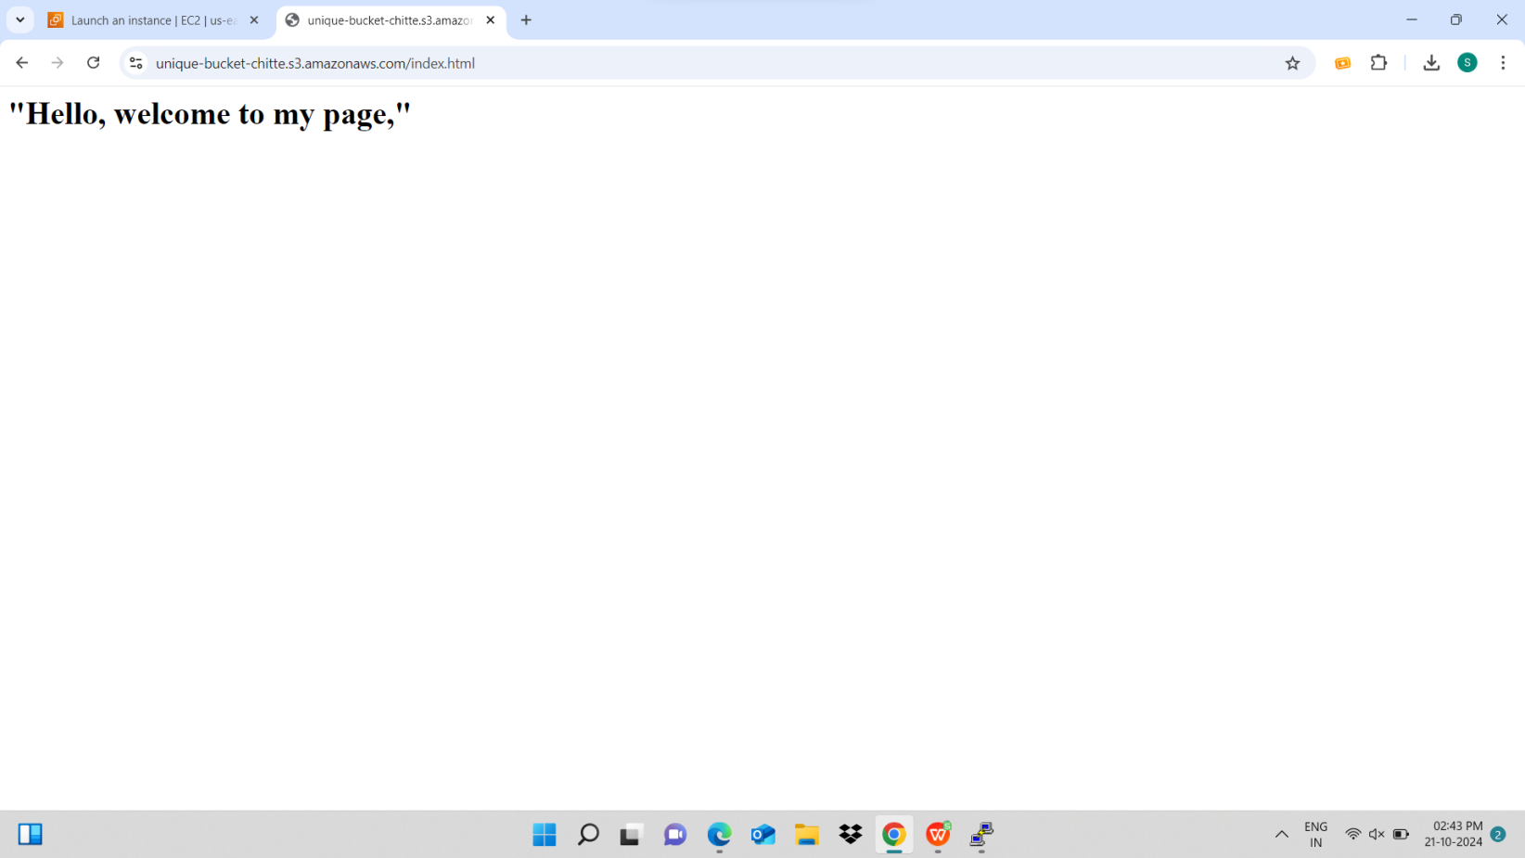

**Now if I will terminate the instance in user I will reflect on the another user also this is start/stop operation Ec2 instance**

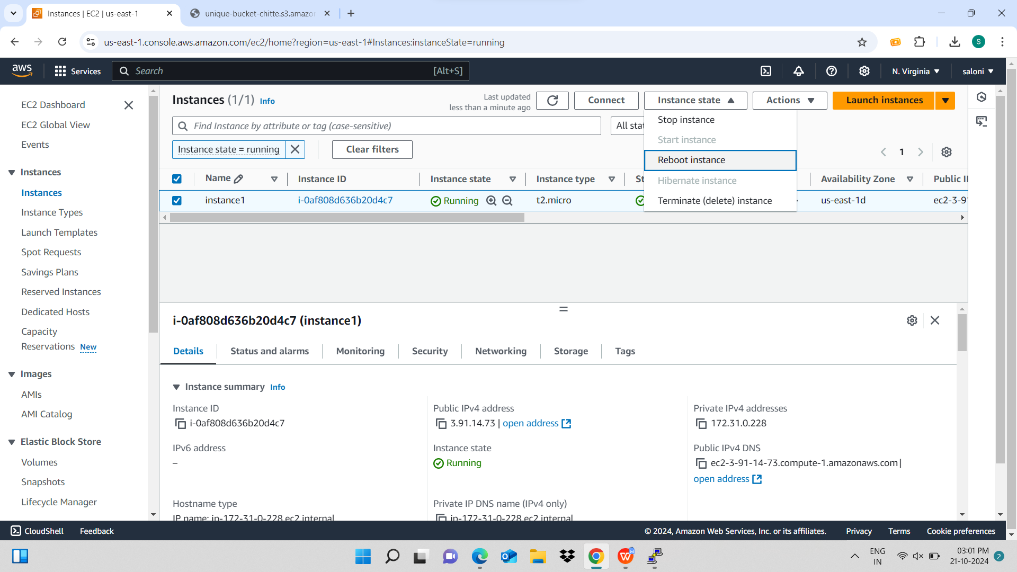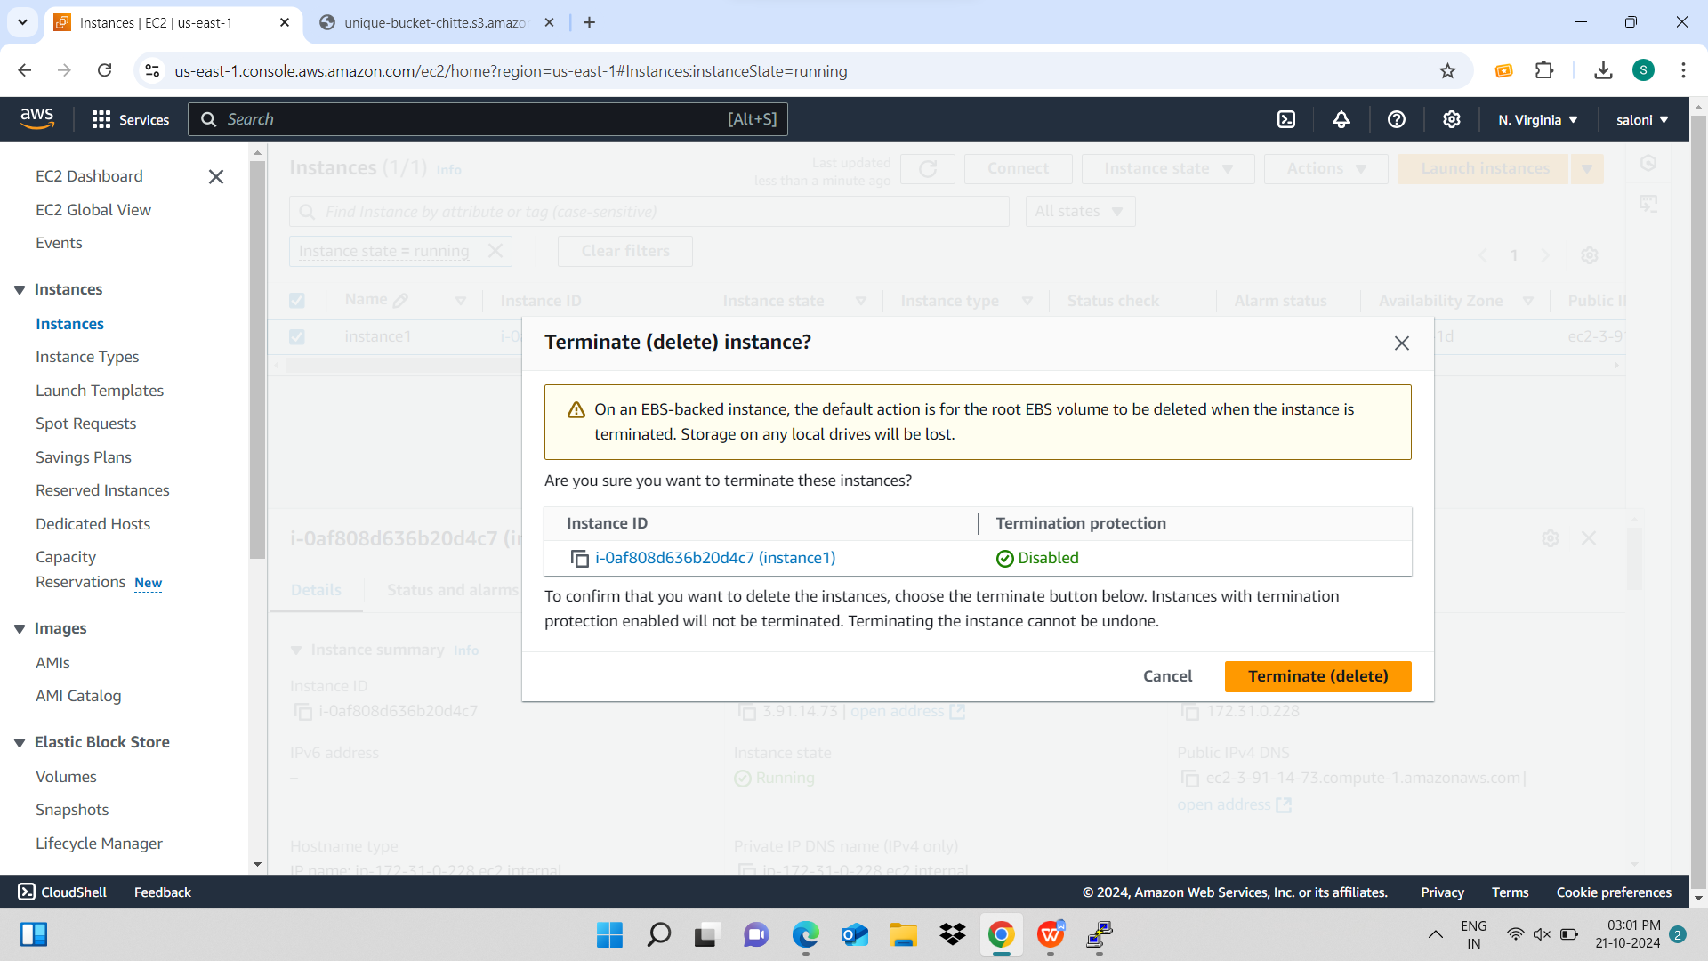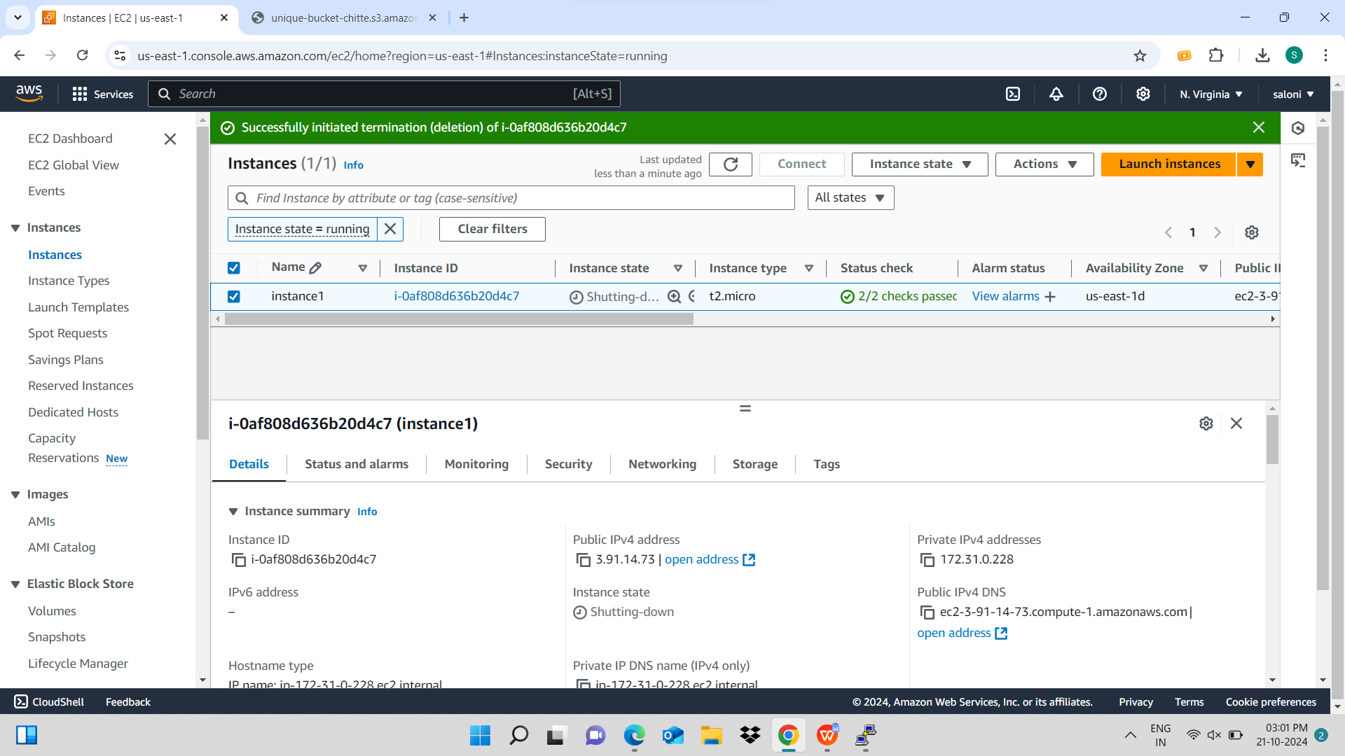

**Instance is terminated in another user also**

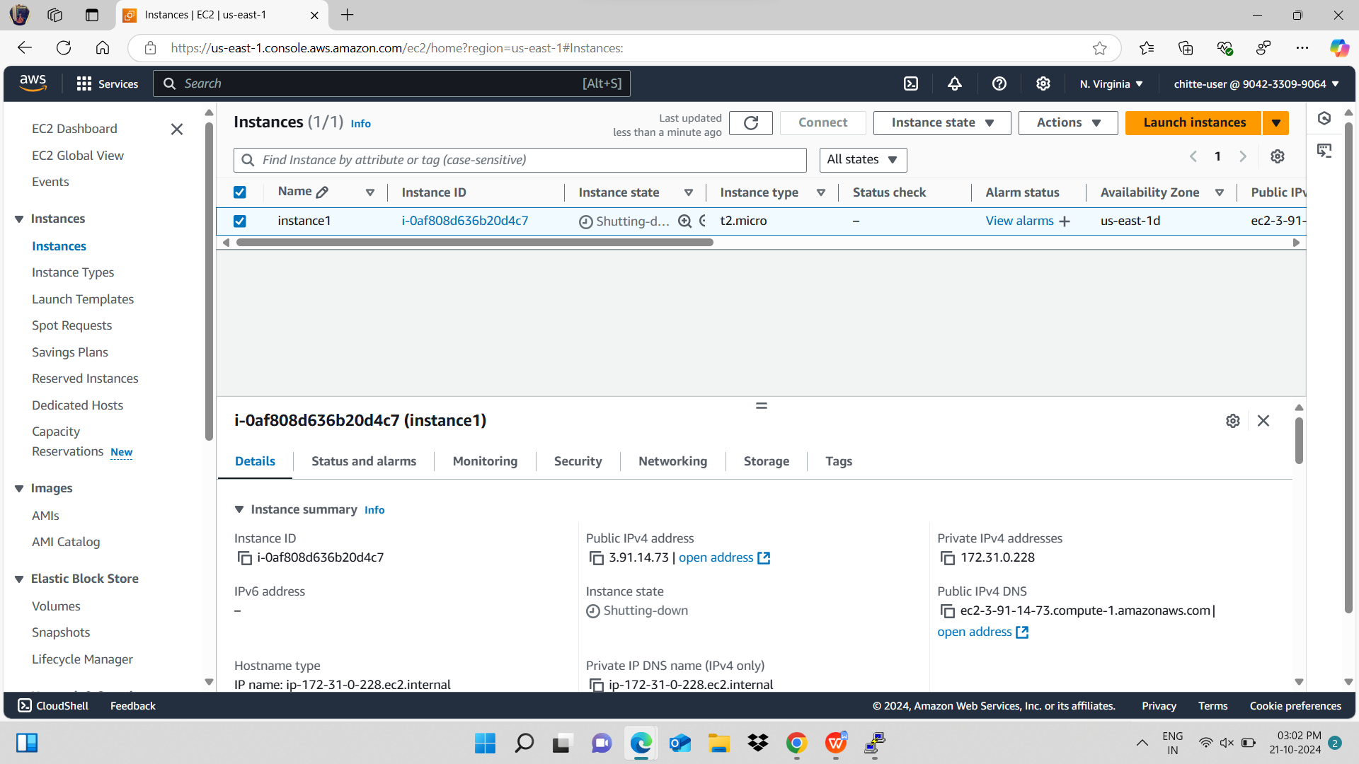

**LINUX**

**Q.2**

**mkdir mydirectory**

**ls**

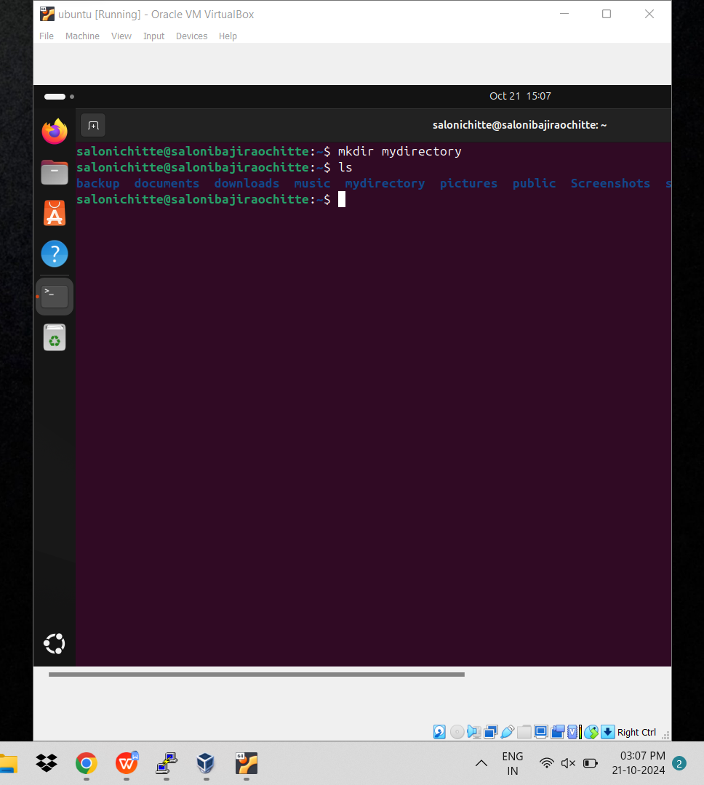

**mv mydirectory new directory**

**ls**

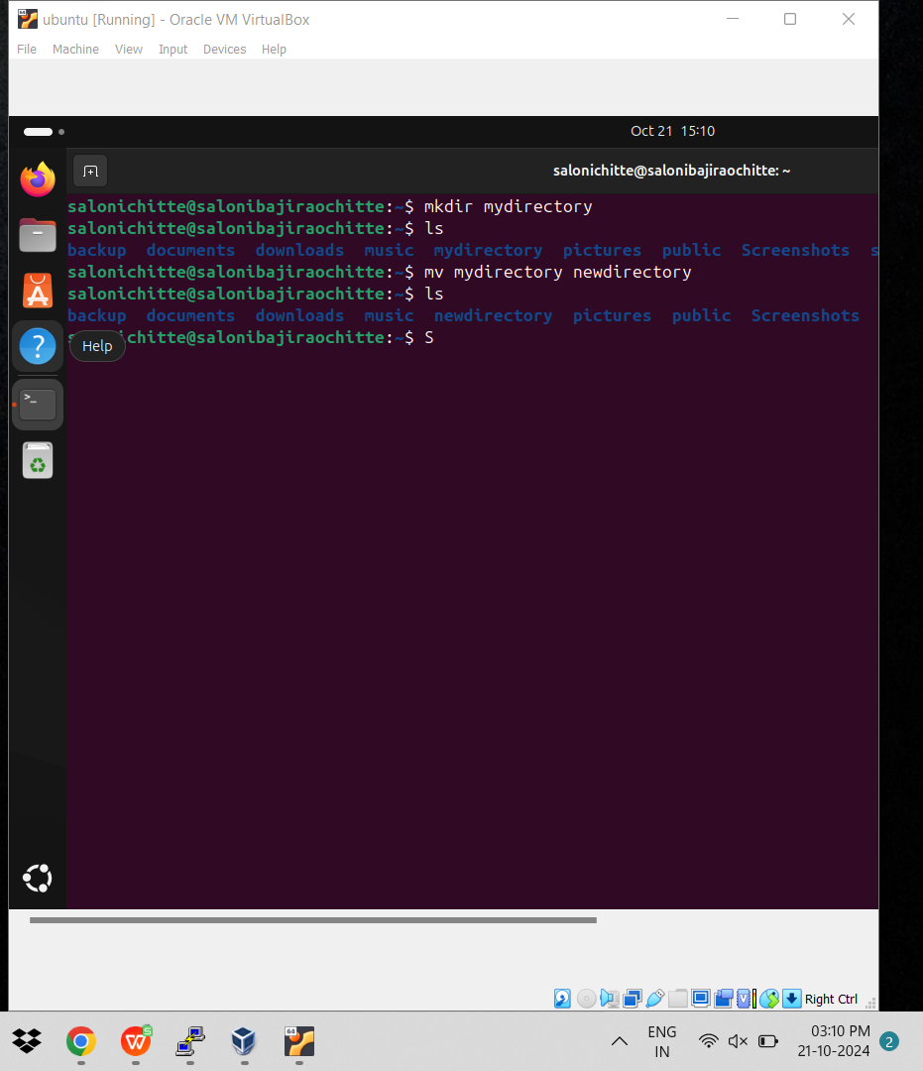

**mv newdirectory /home/salonichitte/backup/**

**cd backup**

**Ls**

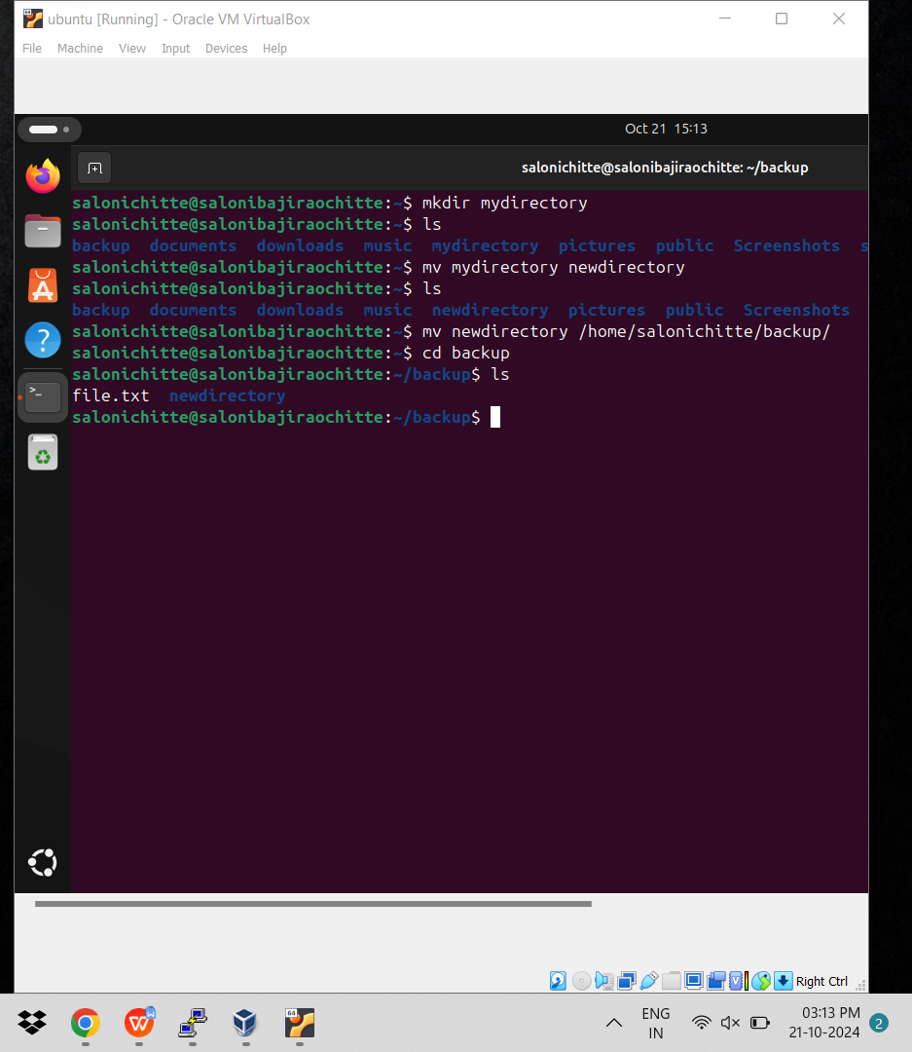

**rm -r newdirectory**

**Ls**

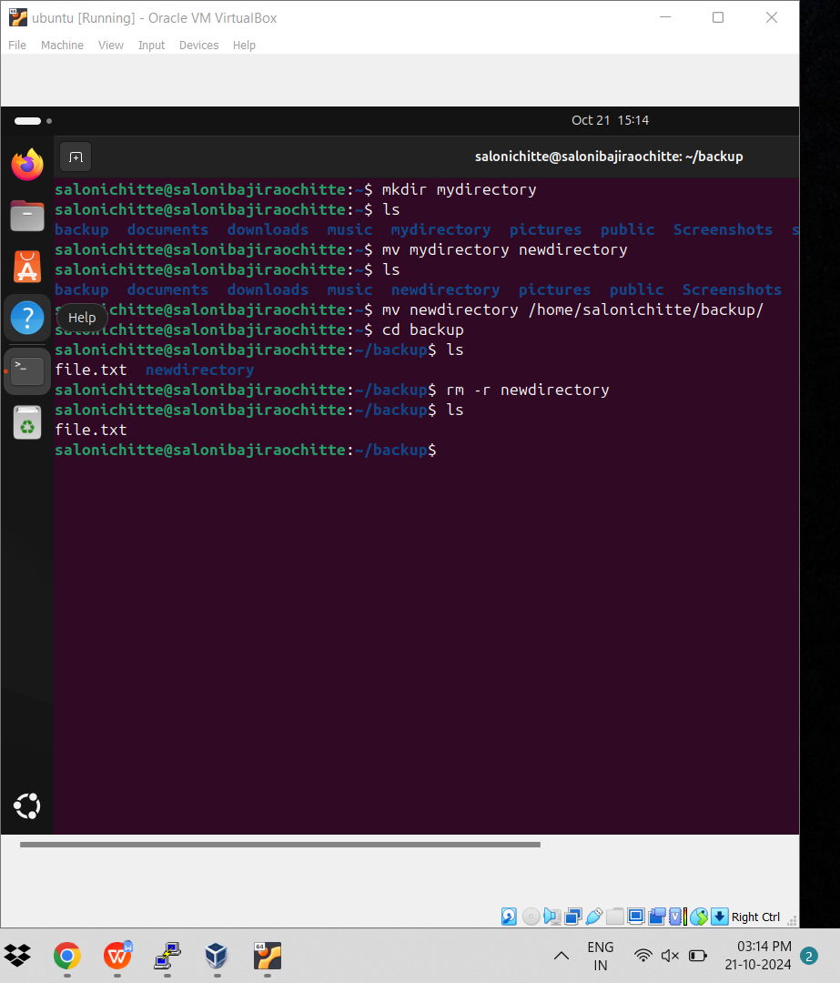

**mkdir mydir**

**cd mydir**

**touch file.txt**

**ls**

**chmod u=rw,g=rw file.txt**

**ls -l**

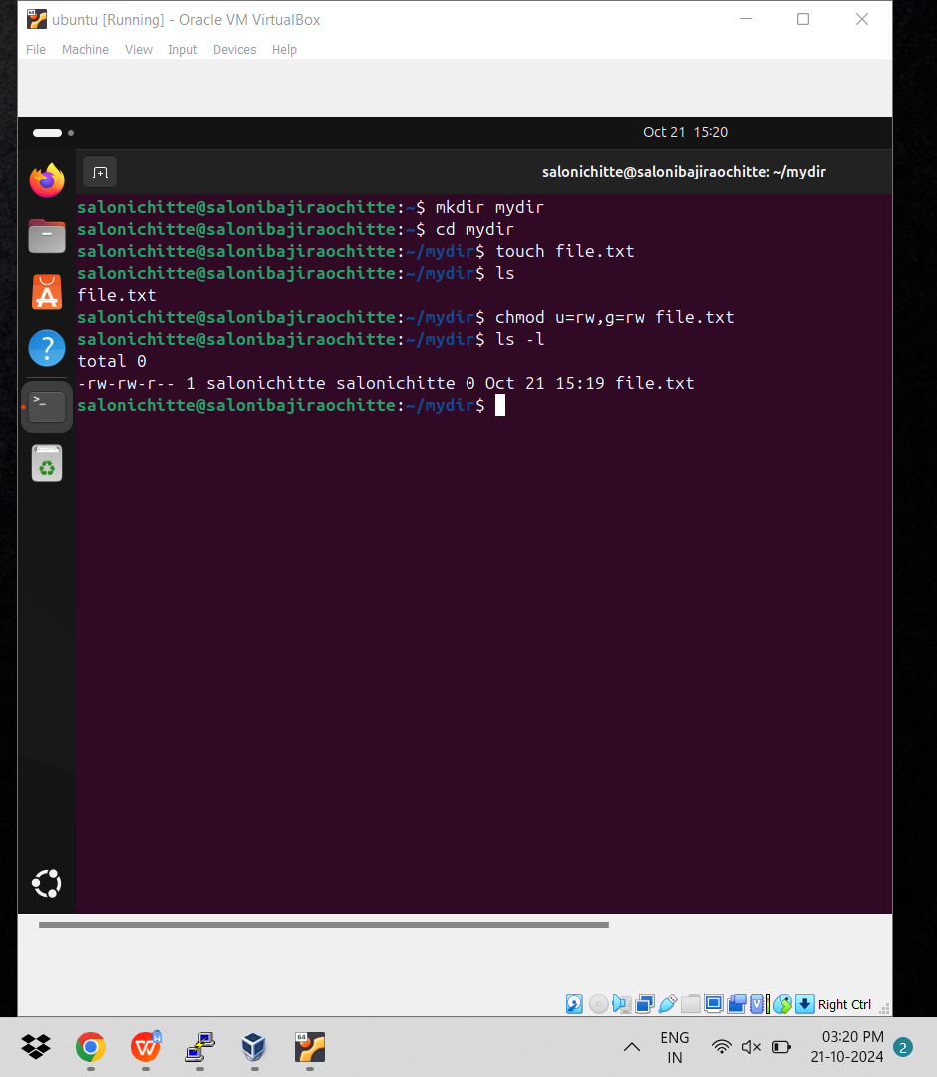

Que 1

2)

#!/bin/bash

Nano que.sh

read a

read b

read c

echo “enter the number ${a}”

echo “enter the number ${a}”

echo “enter the number ${a}”

avg=$((a+b+c/3))

echo “avg”

bash que.sh

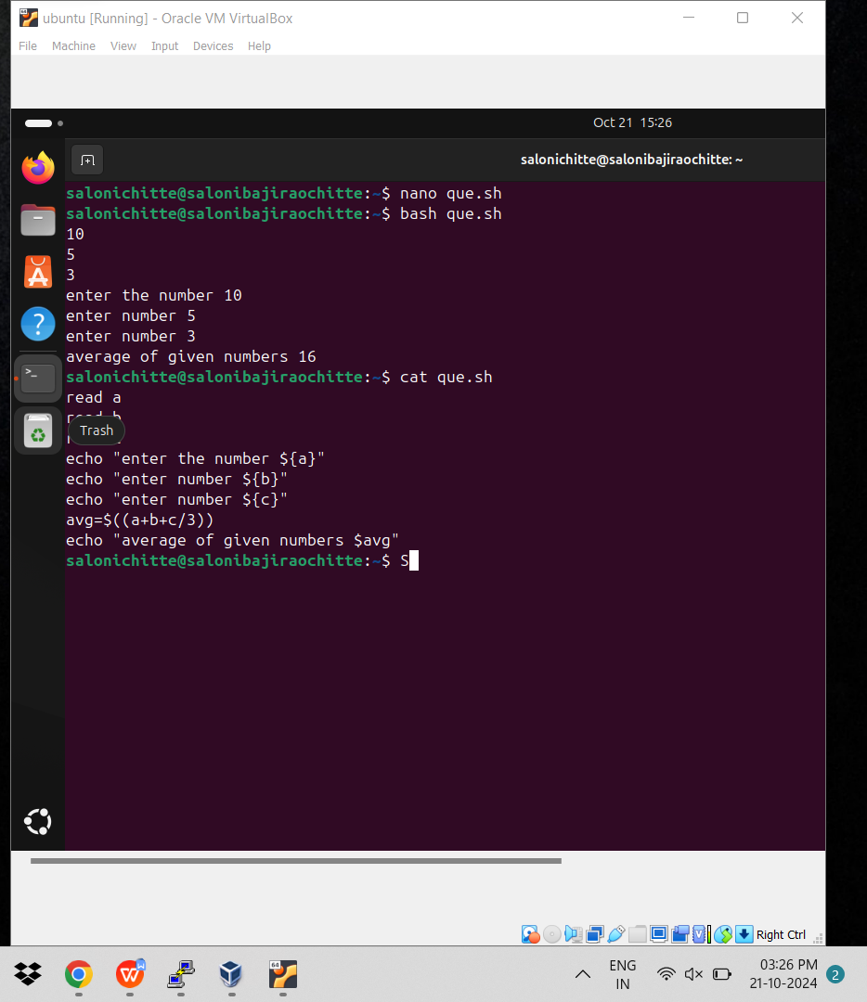

3)

nano que3.sh

read s

echo “enter num ${s}”

Square=$((s*s))

echo “eneter num ${s}”

bash que3.sh

